

Adaptive agribulk terminal planning in light of an uncertain future

Terminal Design Optimization

[Cover date: 22 October 2018]



This page will be removed

Terminal Design Optimization

W. IJzermans

|  |  |  |
| --- | --- | --- |
| Supervisor: | Prof. Dr. ir. M. van Koningsveld | TU Delft |
| Thesis committee | Dr. ir. C. van Dorsser | TU Delft |
|  | Dr. Ir. D. Schott | TU Delft |
|  | MSc. R. Cornelisse | MTBS |

# Preface

This research has been conducted as part of my masters graduation from the Hydraulic Engineering faculty, at the TU Delft. The academic procedure leading up to this point has come with its challenges and I would like to use this opportunity to sincerely express my thanks to the many people that have provided me with their support and guidance throughout the process.

The research has been performed in collaboration with Martine & Transport Business Solutions (MTBS), a port consultancy firm based in Rotterdam, that has provided me with an excellent environment to conduct my work. Being able to brainstorm with colleagues that are very much into the day to day business of assessing terminals investments, ensures the research is in line with actual projects found throughout the world.

To start off, I would like to thank my professor, Mark van Koningsveld, for finding time within a busy schedule to sit together for extensive brainstorm sessions revolving around the development of the terminal tool used within this report. The sessions helped me to convert ideas into programmable concepts, while encouraging me to continuously scrutinize model results in order to ensure they were correct.

Furthermore, I would like to thank my co-supervisor, Cornelis van Dorsser for his unwavering support throughout my entire graduation process. Cornelis and I have sat together and thought about the concept of bringing finance and engineering together for quite some time before I started with this research. His extensive expertise in forecasting and his background in port masterplanning during his time at Royal HaskoningDHV has helped me to stay on track all these months.

In addition, I would like to express my thanks to my other co-supervisor, Dingena Schott. Dingena has helped me to ensure that the focus of this research builds on previous findings within our research field. With her research into dry bulk terminals and her expertise regarding terminal superstructure she has helped to finetune the findings within this research.

Finally, I would like to thank Ryan Cornelisse, my colleague and supervisor at MTBS, for guiding me through this extensive process. Ryan has helped me to formulate my goals and was always willing to reserve time to evaluate my progress. His experience with dry bulk terminals gave me the chance to bring academic literature and empirical business logic together, which I have always deemed as an important component of this research.

Wijnand IJzermans

Rotterdam, December 2018

# Executive Summary

### Keywords

Dry bulk, traffic forecasting, construction costs, grain terminals, marine terminal design, terminal design rules, demurrage costs, etc. etc.

### Summary

**Last sentence of the summary should recap the essence of the entire summary**

Index

[Preface 1](#_Toc530040748)

[Executive Summary I](#_Toc530040749)

[Keywords I](#_Toc530040750)

[Summary I](#_Toc530040751)

[1 Introduction 1](#_Toc530040752)

[1.1 Background 1](#_Toc530040753)

[1.2 Problem Statement 2](#_Toc530040754)

[1.3 Research Objective 4](#_Toc530040755)

[1.4 Thesis Outline 5](#_Toc530040756)

[The Trade in Agricultural Commodities 7](#_Toc530040757)

[2 Agricultural Commodities 8](#_Toc530040758)

[2.1 Commodity scope 8](#_Toc530040759)

[2.2 Commodity Trends 9](#_Toc530040760)

[2.3 Conclusions 15](#_Toc530040761)

[Agribulk Terminals 17](#_Toc530040762)

[3 Terminal Characteristics 18](#_Toc530040763)

[3.1 Vessel characteristics 18](#_Toc530040764)

[3.2 Terminal elements 19](#_Toc530040765)

[3.3 Terminal elements - Quay wall 20](#_Toc530040766)

[3.4 Terminal elements - Unloading equipment 25](#_Toc530040767)

[3.5 Terminal elements - Storage facilitites 26](#_Toc530040768)

[3.6 Terminal elements - Hinterland loading facilitites 27](#_Toc530040769)

[3.7 Terminal elements - Conveyors 28](#_Toc530040770)

[4 Terminal Modelling 44](#_Toc530040771)

[4.1 Existing terminal models 44](#_Toc530040772)

[4.2 Modelling - Quay wall 45](#_Toc530040773)

[4.3 Modelling - Unloading equipment 48](#_Toc530040774)

[4.4 Modelling - Conveyors 49](#_Toc530040775)

[4.5 Modelling - Storage facilitites 50](#_Toc530040776)

[4.6 Modelling - Hinterland loading facilitites 51](#_Toc530040777)

[The Terminal Model 52](#_Toc530040778)

[5 The Terminal Model 53](#_Toc530040779)

[5.1 Modelling objective 53](#_Toc530040780)

[5.2 Key performance indicators 53](#_Toc530040781)

[5.3 Model structure 54](#_Toc530040782)

[5.4 International applicability 54](#_Toc530040783)

[5.5 Triggering investments within the simulation 54](#_Toc530040784)

[5.6 Significant factors for terminal design 54](#_Toc530040785)

[5.7 Increasing terminal flexibility 55](#_Toc530040786)

[6 Making Traffic Projections 56](#_Toc530040787)

[6.1 Traffic scenario’s 56](#_Toc530040788)

[6.2 Traffic forecasting 57](#_Toc530040789)

[6.3 Application within the model 59](#_Toc530040790)

[7 Assessing Design Assumptions 60](#_Toc530040791)

[7.1 Conventional design assumptions 60](#_Toc530040792)

[7.2 Assumption assessment 60](#_Toc530040793)

[7.3 Results 60](#_Toc530040794)

[7.4 Conclusions 60](#_Toc530040795)

[8 The Added Value of Forcasting 62](#_Toc530040796)

[8.1 Making design rules forecast compatible 62](#_Toc530040797)

[8.2 The forecasting window 62](#_Toc530040798)

[8.3 Quantifying the added value of forecasting 62](#_Toc530040799)

[8.4 Conclusions 62](#_Toc530040800)

[Case Study 63](#_Toc530040801)

[9 An Import Terminal in Africa 64](#_Toc530040802)

[9.1 Why Africa? 64](#_Toc530040803)

[9.2 Terminal location 64](#_Toc530040804)

[9.3 Applied economic projections 65](#_Toc530040805)

[9.4 Resulting terminal 66](#_Toc530040806)

[9.5 Conclusions 66](#_Toc530040807)

[Conclusions and Recommendations 69](#_Toc530040808)

[10 Conclusions 70](#_Toc530040809)

[10.1 Research into investment triggers 70](#_Toc530040810)

[10.2 The added value of integrating forecasts into the design process 70](#_Toc530040811)

[11 Recommendations 72](#_Toc530040812)

[11.1 Investment triggers 72](#_Toc530040813)

[11.2 Forecasting mechanism 72](#_Toc530040814)

[11.3 Expand terminal element scope 72](#_Toc530040815)

[11.4 Expand project phase scope 72](#_Toc530040816)

[Appendix 73](#_Toc530040817)

[1 Model Validation I](#_Toc530040818)

[1.1 Investment triggers I](#_Toc530040819)

[2 Bibliography I](#_Toc530040820)

## Introduction

#### Background

Global demand for agricultural commodities such as maize, wheat and soybeans has soared in the past decades 1. This trend is set to continue, driven by global population growth accompanied by a substantial increase in welfare. In the 19th century, the German statistician Engel observed a positive correlation between per capita food demand and income, ultimately levelling out at high incomes 2. The impact of higher living standards on food consumption can be dissected into three components; increased daily consumption, increased food waste and a dietary shift towards animal products.

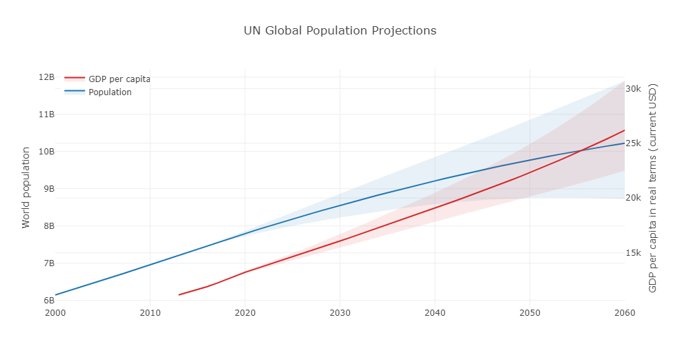

Figure 1.1: Population growth and corresponding GDP per capita figures3,4.

(<https://plot.ly/~wijnandijzermans/42.embed>)

The impact of a global dietary shift to animal products should not be underestimated. Figure x depicts ; currently 36% of the world’s yielded grains and up to 68% of the grains used by developed countries are being fed to livestock5,6. This portion is set to increase, as the past 50 years have seen the global demand for animal products and the amount of crop production used for feed approximately triple (330% and 300% respectively) 7. The increase in food demand will be met with limitations on local production due to regional climates, boosting the global maritime trade in agricultural commodities. The global trends seen in **figure x** underscore the industry’s growth potential and are based on the UN’s yearly population assessment8 and the OECD’s global GDP forecasts9 noted in real terms (i.e. adjusted for inflation and rising cost of services). The potential knock-on effect on global meat consumptions becomes clear when inspecting historic dietary shifts throughout the world, shown in **figure x**. This data combines national averages of meat consumption published by the FAO10 and historic GDP per capita figures, expressed in real terms and translated to current USD published by the World Bank11.

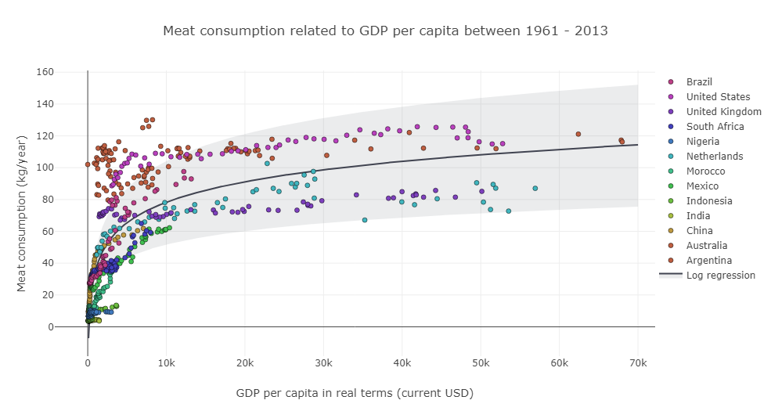

Figure 1.2: Impact of GDP per capita on meat consumption 10,11.

(https://plot.ly/~wijzermans/64)

The three agricultural commodities that fall within the scope of this research are maize, soybeans and wheat, as they all share the fact they are currently traded in substantial volumes and they all show signs of large growth potential. So much so, that grains are one of the major bulk commodity volumes shipped in the world in terms of weight, third only to iron ore and coal 12. Analysis published by shipping agencies such as Clarksons, shown in **figure x**, confirm such trends.

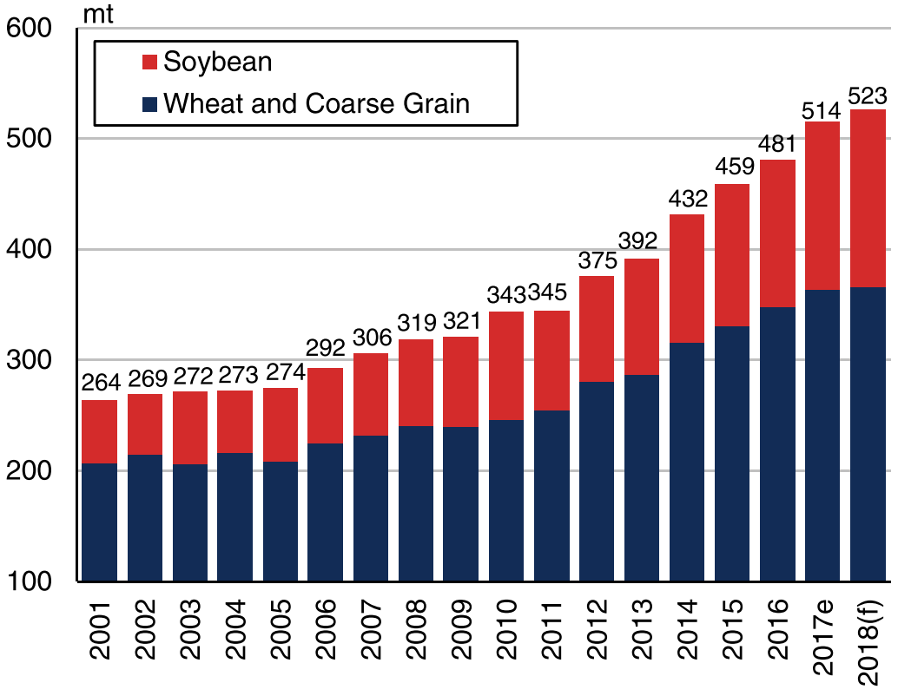

Figure 1.3: Maritime global grain trade volumes 13

#### Problem Statement

This climb in maritime agricultural trade is facilitated through the extensive development of agribulk terminals, which form the interface between long distance maritime trade and different forms of transport found within a terminal’s hinterland. The design of terminals in high-level planning phases (i.e. feasibility phase), has however, not been globally standardized and lacks universal international regulation 14.

As a result of this missing regulation, various guidelines and design rules have been published that are meant to aid terminal developers and port engineers to design terminals. This high-level approach is a crucial step within the design process, as it allows for an evaluation of a project’s feasibility and subsequently forms the basis for the final investment decision. It is important to realize that such guidelines are based on a wide array of empirical studies and often, inevitably, leave quite a spectrum within their recommended dimensioning methods. Current literature lacks studies translating these generalist terminal design rules into a set of rules that can be used to specifically design agribulk terminals, which could lead to a further finetuning of the design methodology.

During the strategic planning phase within a terminal’s development, stakeholders have the most influence on a terminal’s design strategy but are often deprived of extensive and complete technical and economic data (**see figure x**). This impasse is often overcome by designing a terminal using various economic and technical scenario’s. As this is a very time-consuming process, computer models can be of great value, giving the port engineer insight on the consequences linked to various economic and technical design assumptions.

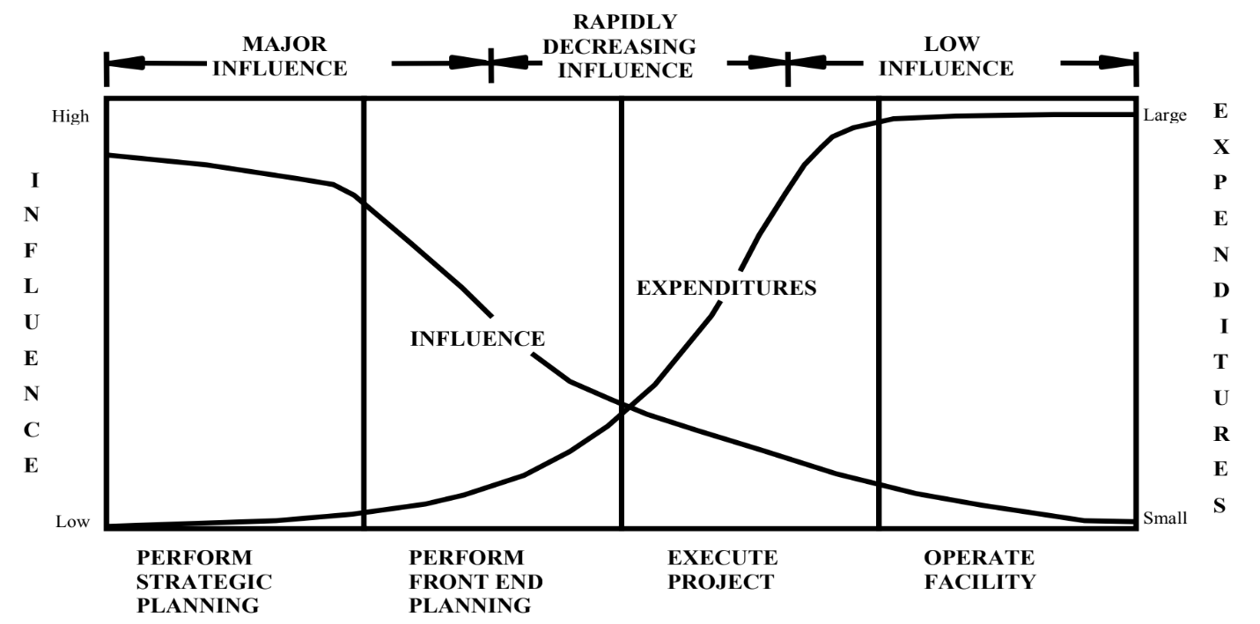

Extensive research has been dedicated to the development of such models 14–20. Many of these models have been verified using comprehensive simulation runs and all include a degree of statistical variability, representing stochastic aspects such as fluctuations in vessel arrivals and varying productivity of terminal equipment. An important characteristic that all these approaches share, however, is their aim to optimize a terminal based on operational expenditures as their key performance indicator (i.e. minimizing the cost per tonne of cargo handled), which is done by assuming a steady-state terminal throughput (i.e. commodity demand is time-invariant).

However, terminal planning can also be approached from a financial perspective, in which the primary aim is to design a terminal which is financially feasible. It is important to note that feasibility can be interpreted in various ways, depending on the stakeholder in question; investors may see a project as feasible if it returns sufficient profit, whereas banks may find it more important that a project pays itself back within a certain timeframe for instance. Such objectives result in different terminal design approaches, starting in a project’s feasibility phase. Yet, this phase within a terminal’s development is still rather segregated; economists make traffic projections, after which a port engineers translate that projection into a terminal plan, before having an economist re-evaluate the terminal plan and analyze its feasibility. This results in a very coarse feedback mechanism in which the final economic analysis may require the port engineers to redo their initial design, leading to an increase in design costs. Developing a tool capable of operating on such a techno – financial interface will help bridge the gap between both parties and hopefully streamline this feedback mechanism. In order to do so, the tool will have to combine technical and operational aspects such as vessel waiting times and throughput seasonality with financial aspects such as capital exposure and the cost of risk while evaluating design decisions.

#### Research Objective

This research is fundamentally multi-disciplinary in nature, as it sets out to define an optimal set of terminal design rules that is based on technical, operational and financial considerations regarding the development of agribulk terminals, including the effect of temporal mutations in traffic demand. The objective of such a set of design rules is to maximize a terminal’s financial value throughout its technical design process. This can be done by evaluating and rewriting the design rules that are applied within the project’s feasibility phase in order to maximize the terminal’s net present value taken over the entire project’s cycle.

The objective of this research can therefore be summarized by asking the question “*Can the conventional design guidelines for terminal planning be optimized for agribulk terminal applications from a terminal’s feasibility perspective*”. This can subsequently be broken down into the following sub questions.

* + 1. Translating generic guidelines to agribulk guidelines

Generalist, existing design guidelines will form the basis for the agribulk terminal guidelines presented in this research. However, these guidelines will be optimized by simulating a terminal’s financial performance under various economic scenarios.

1. *What terminal elements fall within the scope of this study and what are their characteristics*
2. *What are the conventional design rules associated with each terminal element.*
3. *How is each element respresented within the developed computer tool?*
4. *What are the key performance indicators against which design rules can be assessed?*
5. *Is there room for improvement within these conventional design rules from an agribulk terminal perspective?*
   * 1. The added value of forecasting

Changing traffic volumes in previous years could be used to make a projection for the future. Is there any added value in pegging design guidelines to such forecasts? Similar to the approach stipulated above, the added value of forecasting will be assessed by simulating a terminal’s financial performance under various economic scenarios.

1. *How is a traffic forecast formed?*
2. *How would convential design rules have to be rewritten in order to be pegged to such a traffic forecast?*
3. *When basing design rules on future traffic flows, how far into the future should one look?*
4. *What is the added value of using design rules based on traffic forecasts?*

#### Thesis Outline

The global outline of this thesis is depicted in **figure x**, in which the various topics leading up to the conclusion are subdivided into dedicated chapters.

**Pending:** Chapter to chapter summary including references linking to sections within this report

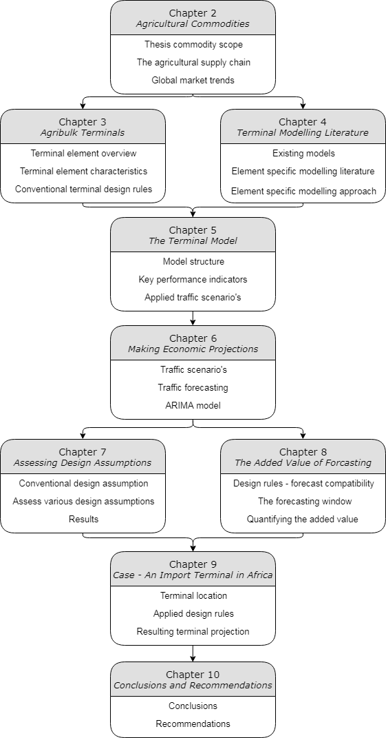



# The Trade in Agricultural Commodities

## Agricultural Commodities

The literature study into commodity trends set out to identify what type of bulk terminals that can expect substantial development in the coming years, making them an interesting subject for further research. The initial focus of this research was on optimizing terminals that were specialized in the handling of major industrial commodities such as iron ore and coal. However, it quickly became clear that most of these terminals are dedicated to large import/export facilities such as power plants (import) and mines (export). However, such dedicated terminals are increasingly owned by the same companies that own the mines and powerplants that are being supplied by the port, as a result of a global push for vertical supply chain integration. This causes a conflict with this research’s objective, as project feasibility of an individual terminal often becomes subordinated to the phasing strategy of the underlying power station or mine. The current agricultural maritime trade, on the other hand, has not seen the same extend of vertical integration. Coupled with the fact that the sector is on the verge of substantial growth, makes research into agribulk terminals intriguing and relevant.

#### Commodity scope

This research focuses on terminals related to the import of wheat, maize and soybeans, as they form the major component of volumes currently traded on the shipping market. This trend is set to continue as all three commodities are deeply embedded in global diets. Wheat, for instance, provides 20% of the daily consumed calories for 4.5 billion people21. Maize is also seen as a staple food, but even in countries where maize is heavily represented in the population’s daily diet, human consumption is heavily outweighed by animal consumption, as is shown in **figure x** 22. This is due to the fact that maize constitutes the major calorie source for feedstock23. For protein, feedstock relies heavily on soybeans through soymeal24, explaining how global soybean demand is being driven by an increase is global meat consumption.

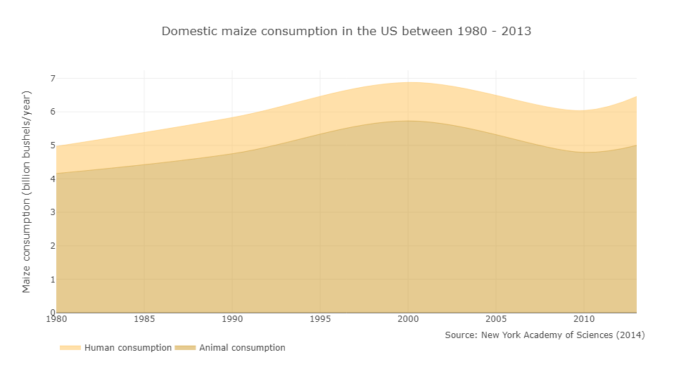

Figure 2.1: Maize consumption in the US

#### Commodity Trends

Global production of agricultural commodities is highly concentrated. So much so, that in 2017 the four major exporting countries; US, Brazil, Argentina and Ukraine accounted for over 70% of global maize export. When examining soybean trade flows, the consolidation is even more severe with the US, Brazil and Argentina serving 80% of the global trade flows25. This global consolidation of crop production leads to large intercontinental shipping volumes, which in turn stimulates the development of agribulk terminals

The maritime trade trends regarding wheat, maize and soybeans are best understood when analyzing respective consumption and production patterns, as a nation’s trade potential can be defined as the difference in domestic consumption and domestic production. This chapter will elaborate on such patterns, in which correlations related to crop consumption are further dissected into human consumption and animal consumption. These findings will ultimately form the basis for future projections that can be used as input for the terminal model. As population growth and an increase in welfare form the main drivers for crop demand2, there are two regions of key interest when looking at global trade trends:

|  |  |  |
| --- | --- | --- |
|  | China | China, with a population of over 1.41 billion people8, boasts the strongest GDP growth figures in the world26 and is already witnessing a strong shift in dietary composition. The average meat consumption increased from 3.8 to 61.8 kg per capita between 1990 and 2013 and this trend is set to continue10,27. |
| C:\Users\Wijnand IJzermans\Desktop\Temp\noun_194336_cc.png | Africa | Africa’s population growth rates are the highest in the world and are expected to lead to an estimated 4 billion inhabitants on the continent at the turn of the century8. Although somewhat delayed, a phase of extensive economic development is expected to boost GDP growth over the coming decades2. |

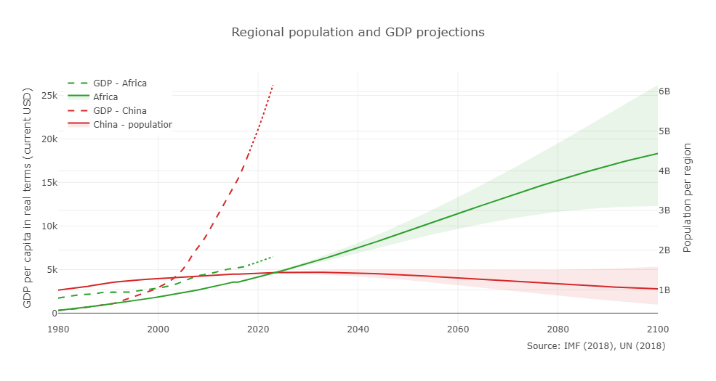

Figure 2.2: GDP and population trends 8

In this research it has been assumed that China is further in the development of their required agribulk terminals in comparison to Africa, partly because demand in Africa is yet to mature. This chapter will therefore predominantly focus on the commodity trends in sub-Saharan Africa, as this region will be responsible for the lion’s share of the continent’s pending population boom, making it relevant for agribulk terminal developments.

* + 1. Human consumption

The extent to which a commodity is linked to either human or animal consumption differs. In Africa for instance, wheat and maize form a major component in the population’s daily diet, whereas soybeans do not play any significant role in human consumption (see f**igure x**).

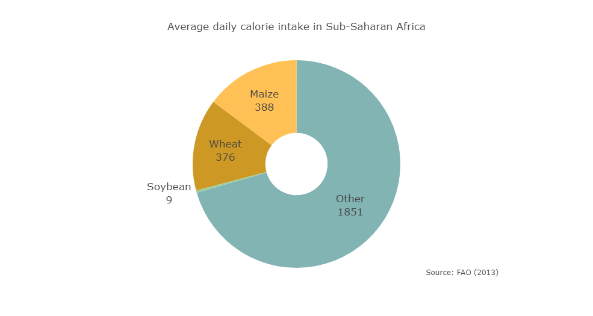

Figure 2.3: Average daily calorie intake in Sub-Saharan Africa

Human consumption is driven by population growth and, to a lesser extent, welfare. However, in regions with showing low GDP figures such as Sub-Saharan Africa, welfare is especially influential in regions with low GDP per capita, such. F**igure x** depicts how food consumption surged in Sub-Saharan Africa as GDP per capita increased6.

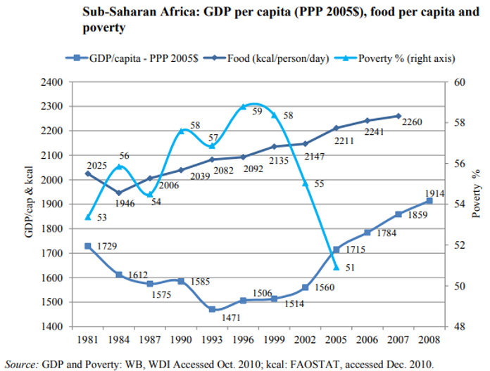

Figure 2.4: Relating GDP to daily calorie intake

How this increase in overall food consumption influences crop consumption differs per commodity. Wheat, for instance, shows a positive correlation with GDP throughout the region, depicted in **figure x**. Consumption data regarding maize, shown in **figure x,** is less conclusive however. It seems that there is a strong variation in maize consumption throughout the region. In Angola and Zimbabwe for instance, maize culturally forms the major staple food in the nation’s diet, whereas in countries such as Nigeria and Ghana this role is fulfilled by other cereals (e.g. millet, sorghum etc.). Furthermore, it seems that maize consumption generally does not increase as GDP per capita rises. The increase is total daily calorie intake is compensated by a dietary shift away from maize to animal products and alternative staple foods, such as wheat.

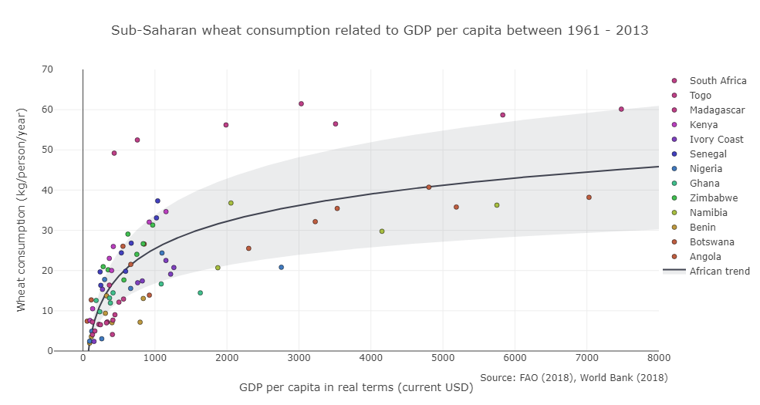

Figure 2.5: Sub-Saharan wheat consumption

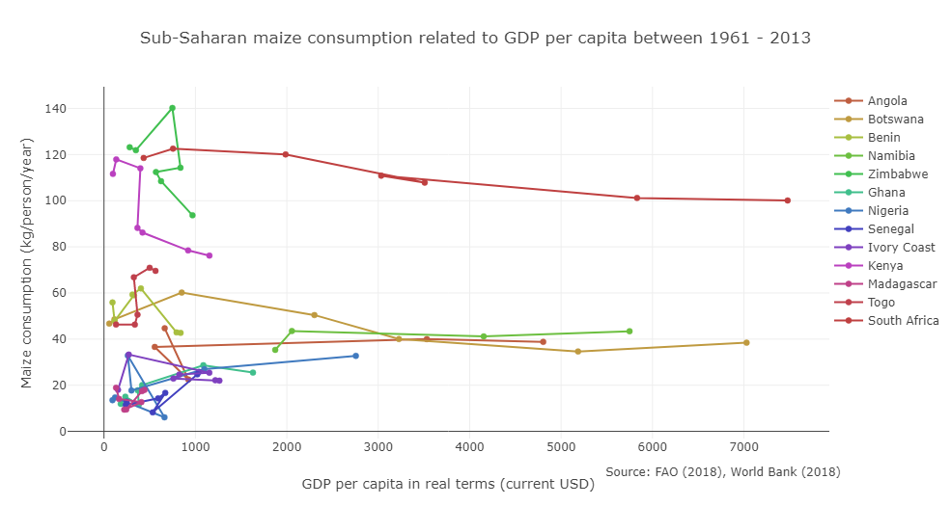

Figure 2.6: Sub-Saharan maize consumption

* + 1. Animal consumption

Currently, about 32 percent of the world consumption of cereals is consumed as feed, whereas in developed countries characterized by high meat consumption, this figure stands at 68 percent, the bulk of it being maize5,6. The interdependency between crop demand and meat consumption becomes clear when examining the amount of feed required to produce a kilogram of meat. **Figure x** depicts a study done by the World Bank into worldwide feed conversion ratio’s, representing the amount of feed required to produce various animal products28.

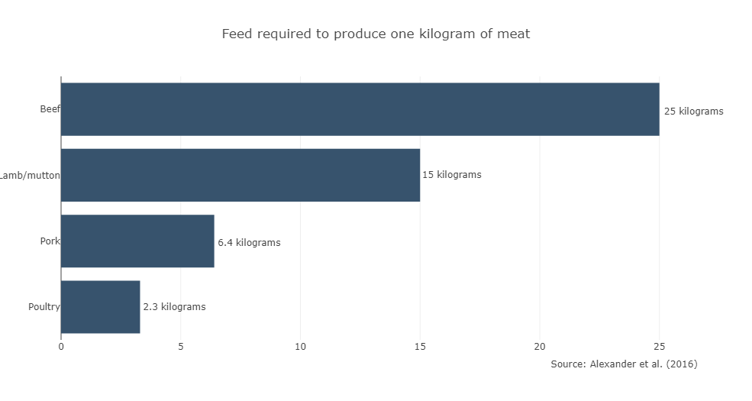

As no literature concerning feed ingredients in Africa was found, this research assumes animal feed to have a similar composition throughout the world. In Germany, the US and New Zeeland, maize conventionally constitutes to about 35% of the dry matter in feed for instance, whereas soymeal represents 9 percent of total feed composition of animal feed in the EU29,30. Empirical data provided by Bunge, a major soybean importer in Amsterdam, shows that 73 percent of imported soybean volumes can be translated into soymeal through dedicated production plants31. All in all, this results in the following assumption regarding animal feed composition, depicted in **figure x**.

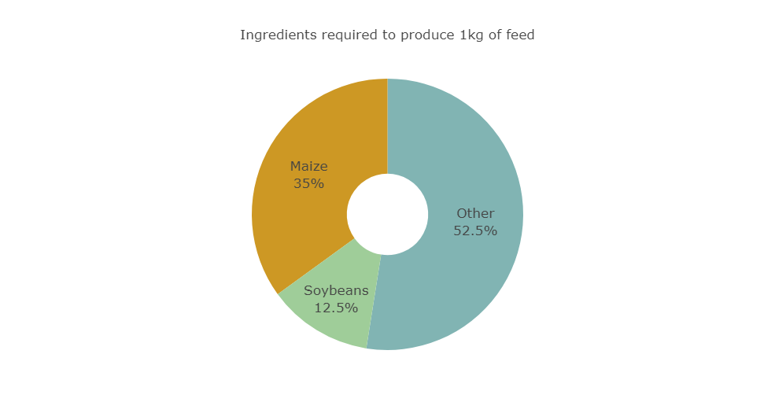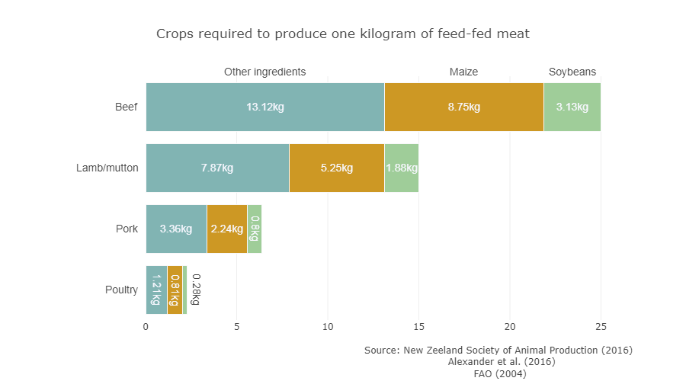

It should be noted that a large portion of global animal products are produced based on non-feed diets (e.g. pastures), withholding their impact on crop demand. Research on the subject estimates that the percentage of animal products based on feed has increased from 27% in 1961 to 44% in 2009, as the large areas required for rangelands and pastures becomes increasingly scarce32. How this feed-fed percentage is distributed over the various livestock groups is not elaborated on and this research therefore assumes that it is homogeneously applicable on all livestock groups.

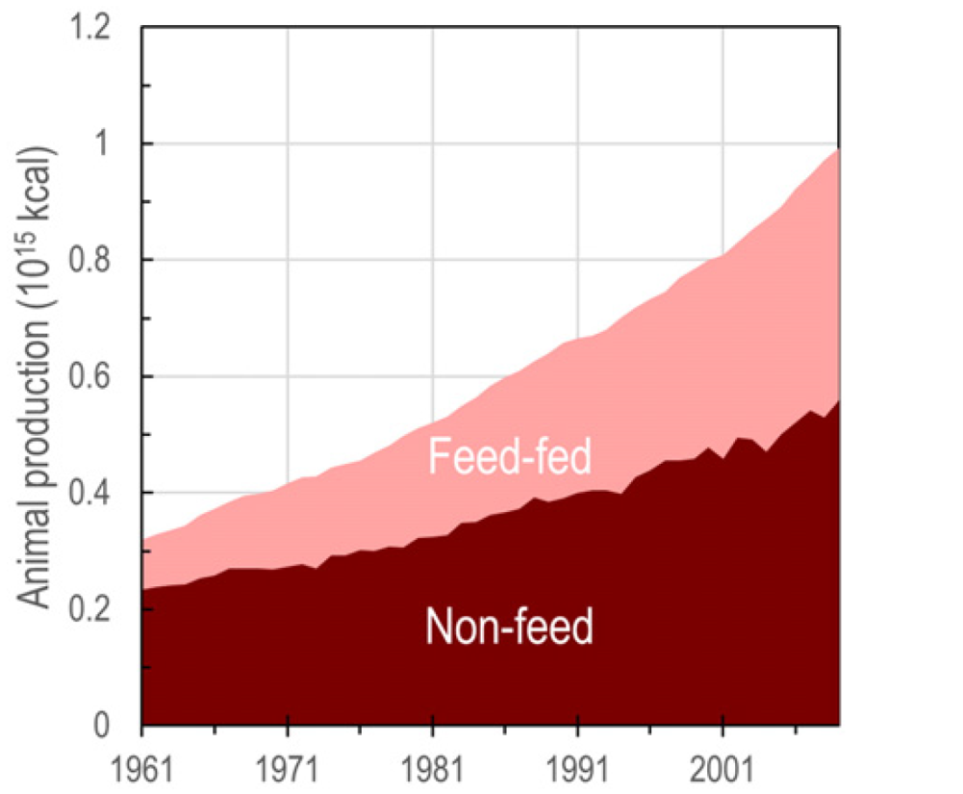

Figure 2.7: Developments regarding feed-fed animal production32

As countries become richer, populations tend to eat more meat, as is shown in **figure x.** This is especially the case in GDP regions up to $10.000 a year. One such example is China, where the surge in the country’s GDP has led meat consumption to increase twentyfold in the past 25 years. There are regions, however, that do not follow this global pattern. One such example is India, where the population clearly eats less meat than other countries with comparable GDP figures. This is probably due to the country’s large Hindu and Muslim populations, in which religion discourages the consumption of beef and pork. Furthermore, it seems that Africa is not following suit either, although current trend analysis is rather preliminary as few sub-Saharan countries have broken into the higher GDP regions. **Figure x** depicts the correlation found within sub-Saharan countries and visualizes the deviation from the global consumption trend.

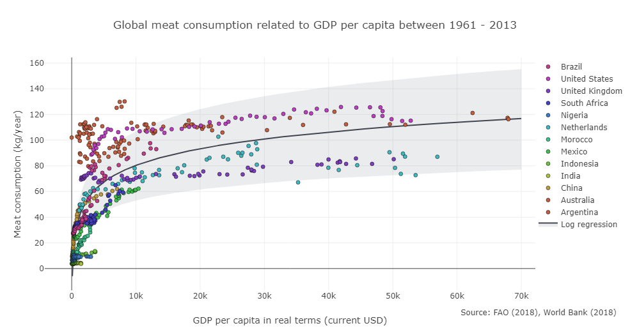

Figure 2.8: Global meat consumption trend

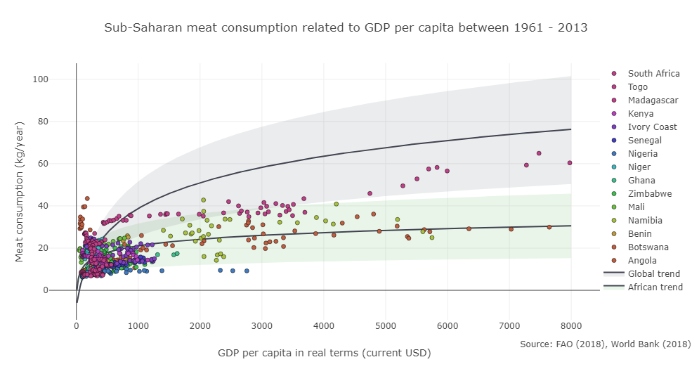

Figure 2.9: Meat consumption trends in Sub-Saharan Africa

* + 1. Crop production

Trade potential for agribulk commodities can be quantified by assessing the difference in the country’s commodity consumption and production capacities. A country’s crop production can be estimated by assessing the land area being used to cultivate a certain crop combined with its corresponding yield. Projections regarding crop area expansion in Sub-Saharan Africa estimate a strong increase (41%) in agricultural area used for the production of maize, whereas almost no increase in areas destined for wheat cultivation are foreseen6. Soybean production has barely developed on the continent and this may explain why no literature was found regarding projections for agricultural area destined for the production of soybeans.

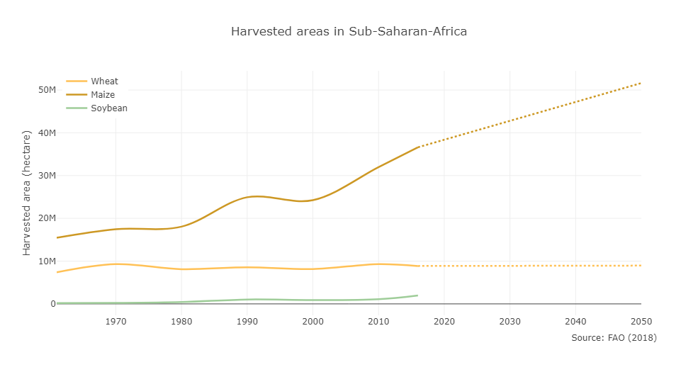

Figure 2.10: Areas destined for crop cultivation

Despite having large areas destined for agriculture, sub-Saharan Africa suffers from underdeveloped farming practices, resulting in low agricultural productivity efficiencies, or yields. However, as welfare and education will continue to improve over the coming decennia, farming practices are expected to improve. Closing the yield gap in Sub-Saharan Africa would increase and diversify global production away from the two major net-exporting regions in North and South America. **Figure x** shows the average crop yields of wheat, maize and soybean found in Sub-Saharan Africa and includes the projected increase in yields, assuming Sub-Saharan Africa is on par with other developing countries by 20506,7.

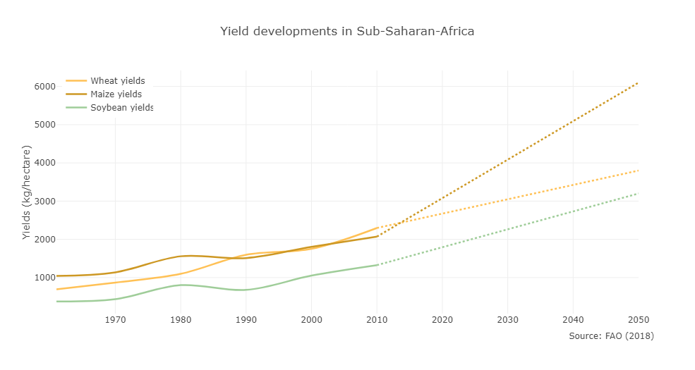

#### Conclusions

This chapter has elaborated on the global trends found within the trade of wheat, maize and soybeans. Aggregated consumption and production trends for Sub-Saharan Africa show large market potential for agribulk terminals, which is the result of a discrepancy between the region’s consumption and production capacities. The increase in the region’s production capabilities, driven by an increase in dedicated agricultural areas and an increase in farming potential will not be able to keep up with the surge in crop consumption. This hike in consumption is a result of an ongoing population boom accompanied by a dietary shift towards animal products, which in turn are increasingly feed-fed. This assumption is backed by long term crop projections published by the FAO, in which Sub-Saharan Africa is clearly flagged as a large net-importing region for all three commodities that fall within the scope of this research.

Chapter 9, *An* *Agribulk Import Terminal in Nigeria*,will translate these regional trends into traffic scenario’s that will be used as input for a terminal case study. Nigeria’s future consumption will be based on GDP per capita and population projections, whereas production will be estimated based on agricultural productivity trends and agricultural policies.

Possible addition:

1. World trade flows visualised
2. Wheat, maize, soybean import-heat-map of Africa

**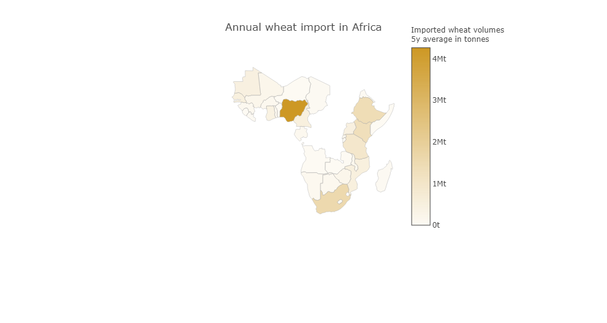**

# Agribulk Terminals



## Terminal Characteristics

This chapter will set out to provide a clear overview of the various elements of an agribulk terminal together with their technical and financial characteristics. This is done through a literature study and combined empirical data gathered during terminal visits within the Netherlands. Existing design guidelines and rules of thumb for each component will also be addressed.

#### Vessel characteristics

Vessel characteristics play a major role in the terminal design process. Vessel sizes greatly influence the required dimensions of maritime infrastructure (e.g. water depth, berth length, etc.) and the call size of the vessel has major implications for the design strategy of the terminal’s superstructure (e.g. cranes, storage, etc.). The vast majority of the agribulk trade is conducted using bulk carriers, cargo vessels in which the loose cargo is loaded directly into a ship’s hold. Bulk carriers can be grouped into classes depending on their cargo capacity, expressed in Deadweight Tonnage (DWT). The vessel dimensions of all registered operational vessels within each class have been averaged for each class and are shown in the **table x**33,34.

|  |  |  |  |  |  |
| --- | --- | --- | --- | --- | --- |
| Vessel class |  | DWT | Vessel length | Vessel breadth | Vessel draught |
| Handysize |  | < 35.000t | 170m | 25.9m | 9.9m |
| Handymax |  | < 55.000t | 192m | 28.1m | 11.5m |
| Panamax |  | < 80.000t | 225m | 32.4m | 14.0m |
| Baby-Capesize |  | < 150.000t | 252m | 41.0m | 16.2m |
| Capesize |  | > 150.000t | 299m | 47.7m | 18.5m |

Table 1: Bulk carrier classes

In the past two decennia, the consolidation of global supply chains has led to ever larger vessels in the shipping sector. Bulk carriers have followed this trend, clearly illustrated in **figure x**. The majority of newbuilt vessel capacity falls within the large *Capesize* class and are used for the shipment of iron ore and coal. Vessels within the agribulk sector have also grown over the recent decennia, be it on a smaller scale.

The relatively confined growth of vessel dimensions in the agribulk trade can be explained by assessing the underlying supply chain. Traditionally, vessel dimensions are governed by port dimensions used for export and as the supply chains of iron ore and coal have become increasingly consolidated, exporting ports have become bigger and bigger. These major export hubs have made investments in deep sea basins feasible, allowing the fleet’s vessel dimensions to increase. The supply chain of wheat, maize and soybeans has also witnessed a degree of consolidation, but to a much lesser extent. Furthermore, a large portion of the production in major exporting hubs such as Amerika and Brazil are located along rivers such as the Mississippi and Amazon. This poses a major constraint for shipping, as the large sediment volumes transported downstream by these rivers make it very costly to dredge rivers beyond their natural depth. In downstream regions of the Mississippi for instance, depths have been dredged, but only to approximately 13m and only until Baton Rouge, LA. Navigation depth quickly deteriorates as you go further upstream, lowering a vessel’s cargo capacity or requiring lightering procedures. This natural cap on vessel dimensions in the agribulk trade has resulted in most of the global shipments to be shipped in the handysize, handymax and panamax vessels. The developed tool will therefore only incorporate these three vessel classes.

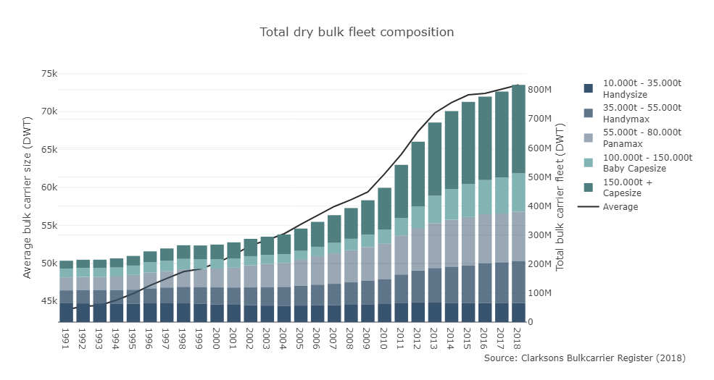

Figure 3.1: The dry bulk fleet

Possible addition:

1. Visualisation of percentage cargo shipped by each vessel type

#### Terminal elements

The remaining sections of chapter three will be dedicated to the maritime infrastructure and superstructure elements that are found within agribulk terminals. Each element will have its own dedicated section with a general introduction, followed by an overview its technical characteristics and the corresponding conventional design rules and assumptions. At the end of each section the financial characteristics of each element are discussed. The terminal elements that fall within the scope of this research are visualized below:

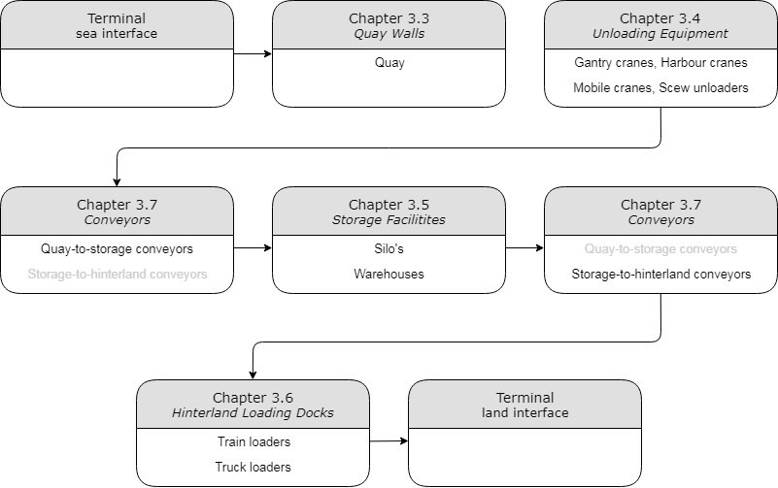

Figure 3.2: Terminal element scope

#### Terminal elements - Quay wall

The quay forms as the interface between arriving vessels and the processes located at the terminal. The quay consists out of berths, allowing vessels to dock for them to be unloaded by specialized equipment stationed at each berth. Within this research, it has been assumed that the quay wall is constructed as a sheet pile quay wall, consisting out heavy primary elements (e.g. tubular piles) with intermediate corrugated steel profiles that are driven into the subsoil and anchored into a patch of stable soil behind the wall (see **figure x and x**). This type of quay wall has been chosen for two reasons; sheet pile walls are often used in cases requiring deep berths and they can be built in soils with low bearing capacities (i.e. clay)35, leading to increased model applicability.

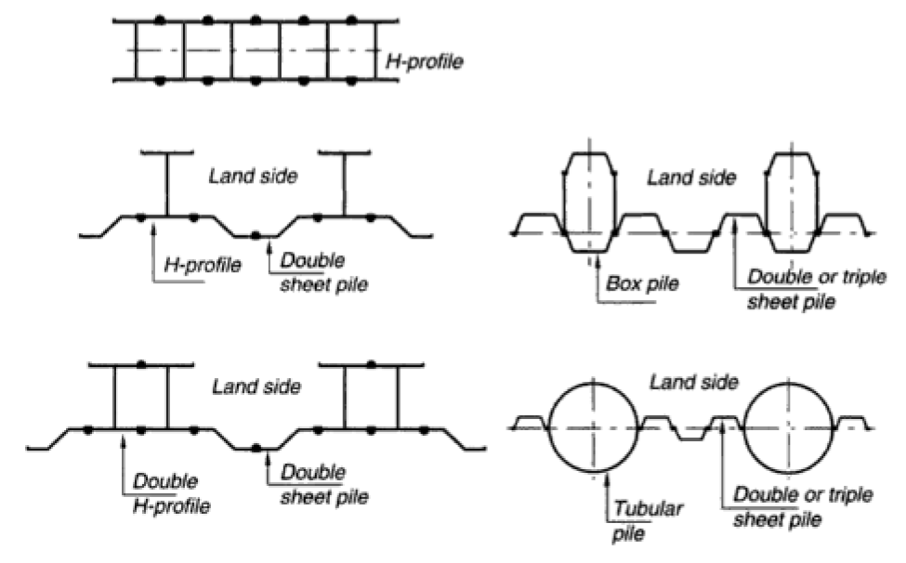

Figure 3.3: horizontal cross sections of various sheet pile quay walls36

* + 1. Design assumptions

There are four technical characteristics that play a role when designing a quay wall in an early design phase; a quay wall’s required freeboard, its retaining height, the number of berths and the resulting length of the quay.

Freeboard

A quay’s freeboard refers to the horizontal clearance between the highest astronomical tide level and the deck. The required freeboard is site specific and is related to the astronomical tide and wave penetration present in the harbor basin. Within the computer model it has been assumed that the required freeboard is 4m.

Retaining height

In the research conducted by de Gijt36,37, quay construction costs have been correlated to the quay’s *retaining height*. The retaining height ($L$) is the entire vertical length of the quay wall; the freeboard ($L_{freeboard}$), the berth depth ($d_{ Quay}$) and the distance the wall has be driven into the seabed ($L_{subsoil}$). Assuming that the sub-soil length is equal to the summated freeboard and berth depth14, as is shown in **figure x**, the retaining height can be expressed as:

|  |  |
| --- | --- |
| $$L=2∙\left(L_{freeboard}+d_{ Quay}\right)$$ | Eq. xx |

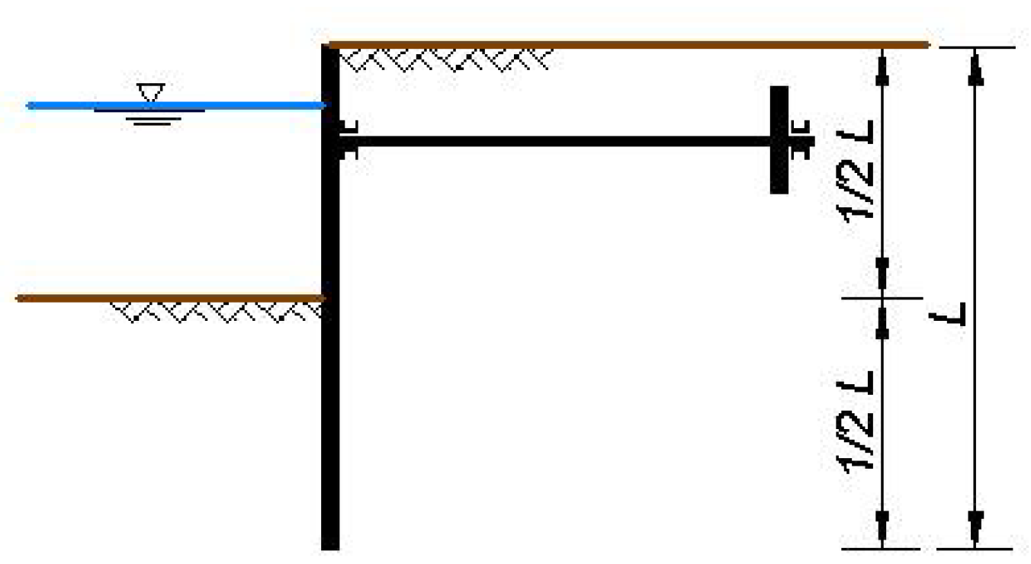

Figure 3.4: A quay wall's retention height

Number of berths

The required number of berths at a terminal is determined by assessing the allowable turnaround time of vessels calling at that terminal. The turnaround time of a vessel ($t_{t}$) is defined as the time it takes for the vessel to be unloaded, or serviced ($t_{s}$), the mooring and demooring time of a vessel ($t_{m}$) and the time it takes for a vessel to wait for an available slot at a berth ($t_{w}$):

|  |  |
| --- | --- |
| $$t_{t}=t_{s}+t_{m}+t_{w}$$ | Eq. xx |

The service time ($t_{s}$) is governed by the callsize of the vessel ($W_{call}$) and the summated unloading productivty of the equipment position at the berth ($P_{unload}$).

|  |  |
| --- | --- |
| $$t_{s}=\frac{W_{call}}{P_{unload}}$$ | Eq. xx |

The unloading capacity of unloading equipment will be treated in detail in Ship Unloading Equipment. Furthermore, it is assumed that the vessel classes that fall within the scope of this research all have a combined mooring and de-mooring time ($t_{m}$) of three hours. Once the service and mooring times are known, the average waiting time of a vessel ($t_{w}$) can be estimated with the help of queuing theory. This approach requires the assumption that the variation in inter-ship arrival times and the service times can be represented through a standardized statistical distribution. These distributions are summarized in a so-called Kendall notation, which is depicted below. The nature of the *vessel arrival distribution (X)* and *service rate distribution (Y)* can be grouped into three classes:

|  |  |  |  |  |  |
| --- | --- | --- | --- | --- | --- |
| *Kendall’s notation:* | *X* | / | *Y* | / | *n* |
| *Vessel arrival*  *distribution* |  | *Service rate*  *distribution* |  | *Number of*  *berths* |

|  |  |  |  |  |  |  |
| --- | --- | --- | --- | --- | --- | --- |
| Negative exponential  distribution (N.E.D) | $$\left(M\right)$$ | *High stochastic variability* |  | $$f\left(t\right)=λe^{-λ∙t}$$ | $$λ=$$ | mean |
| Erlang-k distribution | $$\left(E_{k}\right)$$ | *Less stochastic variability* |  | $$f\left(t\right)=\frac{{\left(k∙μ\right)}^{k}∙t^{k-1}∙e^{-k∙μ∙t}}{\left(\left(k-1\right)\right)!}$$ | $$k=$$ | Kendall - integer |
| Deterministic | $$\left(D\right)$$ | *No stochastic variability* |  | $$f\left(t\right)=constant$$ | $$μ=$$ | Berth utilization |

Extensive research into applicable distributions has been conducted by, among others, van Vianen18. In his research, real-world data was gathered at five unnamed coal and iron ore import terminals (T1 – T5), after which the various stochastic distributions were compared to the terminal’s empirical data in order to find the best fit. His conclusions are summarized in the following table:

Tabel 2: Source: Van Vianen et al. 18

|  |  |  |  |  |  |
| --- | --- | --- | --- | --- | --- |
| Terminal |  | Annual throughput | Number of vessels registered | Best fitted arrival distribution (*X*) | Best fitted service distribution (*Y*) |
| T1 |  | 18 Mt/y | 345 | Weibull/Erlang-2 | - |
| T2 |  | 37 Mt/y | 898 | NED | Erlang-2 |
| T3 |  | 44 Mt/y | 186 | Weibull/Normal | - |
| T4 |  | 16 Mt/y | 115 | Weibull | Erlang-2 |
| T5 |  | 12 Mt/y | 202 | Erlang-2 | Erlang-2 |

Building on the findings presented above, this research assumes that both the vessel arrival and service rate is best represented by an Erlang-2 distribution. This assumption is further justified by the conclusions presented by Kuo et al. 38, which state that stochastic variation increases as a system’s scale grows. As the import terminals for wheat, maize and soybeans are often smaller than the smallest terminal presented above, extrapolating these findings to agribulk terminals can be seen as a conservative assumption. **Figure x** illustrates the correlation between a berth’s occupation and the average waiting time of a vessel, depicted as a fraction of its corresponding service time ($t_{w}/t_{s}$), assuming both vessel arrivals and terminal service rates are representable by an Erlang-2 distribution18,38,39. It is important to note that this approach assumes that each vessel that calls to port can moor at every berth, requiring each berth to be able to accommodate the largest vessels expected to call to the terminal.

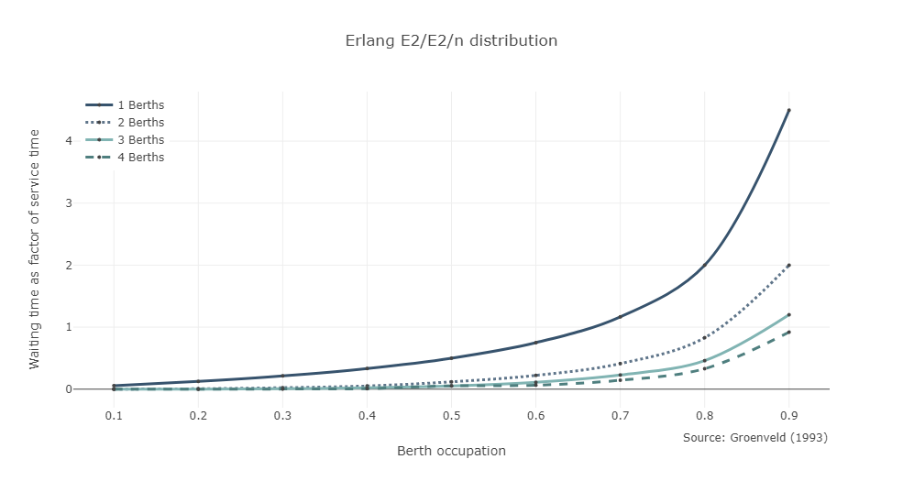

###### Length

The quay is defined as a set of connecting berths built in an elongated straight configuration. Once the required number of berths is known, the resulting quay length ($L_{quay}$) can be calculated using **equation xx**, based on the number of berths ($n$) and the vessel length of the largest vessel expected to call to port () 12.

|  |  |
| --- | --- |
|  | Eq. xx |

* + 1. Financial characteristics

The financial characteristics of each asset within the terminal can be dissected into two groups. The first are characteristics associated with the purchasing of an asset and fall under the category capital expenditures, or CAPEX. The second group of costs are operational expenditures, or OPEX, and incorporate all yearly recurring costs such as maintenance and insurance. All costs named within this section are the *direct construction costs*, which include building materials and labour and exclude contingency and engineering costs. The three CAPEX characteristics of a quay wall that are included in the computer model are the unit cost, the mobilization cost and the construction time, the time between the purchase of an asset and the date the asset comes online.

CAPEX – *Unit cost*

The unit cost, or construction cost per meter quay, is strongly correlated to the required depth of the harbor basin. The empirical relation found by de Gijt even states that up to 75% of the capital expenditures associated with quay walls are related to its retaining height36. The research conducted by de Gijt based its findings on the construction data of over 200 quay walls, which he received from port authorities located throughout the world38. For this research, quay wall data was filtered on projects completed after 1990 with a minimum retaining height of 10m, approximated to guarantee a berth depth of 5m. To further support de Gijt’s conclusions, MTBS project data was included in the comparison which is illustrated in **figure x**. Through polynomial regression, **equation x** summarizes the correlation between the unit price of quay walls ($R_{ Quay}$), expressed in present value US$, and the required depth at the berth ($d_{ Quay}$). With a correlation coefficient of 0.58 the correlation is deemed decent, but a couple of anomalies remain. This might be the result of special circumstances during construction such as difficult soil conditions. Furthermore, it should be noted that the correlation is stronger in the lower depth regions (< 15m), increasing its compatibility with the developed computer model.

|  |  |  |  |
| --- | --- | --- | --- |
| $$R_{ Quay}=834∙{d_{ Quay}}^{2}-9381∙d_{ Quay}+48261$$ | $$\left[{US\$}/m\right]$$ |  | Eq. xx |
| $$C_{ Quay}=R_{ Quay}∙L_{ Quay}$$ | $$\left[US\$\right]$$ |  |

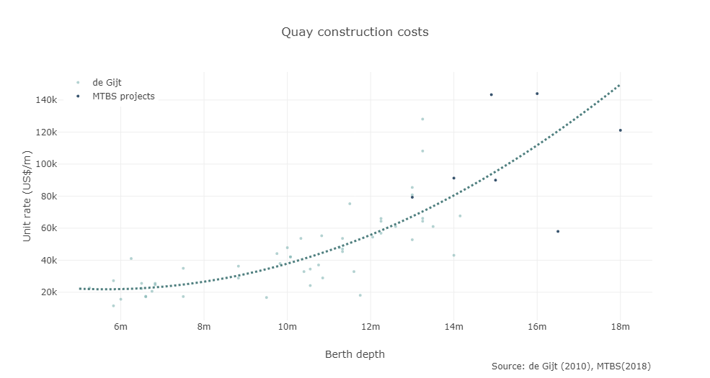

CAPEX – *Mobilisation cost*

The mobilization costs are cost associated with mobilizing the construction equipment, -material and labor force. Based on projects within MTBS, the mobilization costs of quay walls (${MC}_{ Quay}$) are set at 1% of the quay’s unit rate ($R_{ Quay}$) multiplied by its length ($L_{ Quay}$), with a minimum of 2.500.000 US$.

|  |  |
| --- | --- |
| $${MC}_{ Quay}=0.01∙R_{ Quay}∙L_{ Quay} with a mininum of \$2.500.000$$ | Eq. xx |

Now, by combining the unit rate and mobilization cost, the total construction cost ($C_{ Quay}$) of the quay wall can be determined, as is shown in **equation x**.

|  |  |
| --- | --- |
| $$C_{ Quay}=R_{ Quay}∙L_{ Quay}+{MC}_{ Quay}$$ | Eq. xx |

CAPEX – *Time until delivery*

Within the model it is assumed that it takes two years for a quay to become useable after purchasing, irrespective of the length of quay that is to be built.

OPEX – *Maintenance*

In order to guarantee asset continuity, it is standard practice to reserve a yearly budget for maintenance activities. Literature into the subject states that in 2003, the Port of Rotterdam reserved 0.5% - 1.5% of the initial quay investment as yearly maintenance. This is line with the findings made within MTBS and therefore, within the computer model, it has been assumed that 1% of the initial quay investment is required as yearly maintenance.

OPEX – *Insurance*

It is standard practice to insure the assets on a terminal. Based on expertise within MTBS, this research assumes that 1% of an asset’s initial investment is reserved as yearly insurance.

OPEX – *Reinvestment*

When an asset reaches the end of its lifespan, it requires a re-investment, either because it is at risk of collapsing or because maintenance works become increasingly costly as assets become older. In the case of quay walls, current common practice stipulates that quay walls be designed for a lifespan of 50 years. Although this 50-year timeframe outlives the timeframe range of the computer model, it is assumed that depending on an asset’s remaining lifetime, it still carries worth at the end of the model’s timeframe. This is referred to as *depreciation* and it is assumed that this value reduction occurs linearly, as is shown in **equation x**. Asset value ($V$) is related to the asset’s initial cost ($C$), an asset’s age ($t_{age}$) and its excpected lifespan ($t_{lifespan}$).

|  |  |
| --- | --- |
| $$V=C*\left(1-\frac{t_{age}}{t_{lifespan}}\right)$$ | Eq. xx |

#### Terminal elements - Unloading equipment

There are various type of equipment capable of unloading dry bulk vessels. Some do this in a continuous fashion, such as screw unloaders, whereas some cranes are equipped with grabs enabling them to unload vessels in a discontinuous manor40. Besides the vetical screw unloader, three types of discontinuous unloaders have been included in the scope of this reserach; gantry cranes, harbor cranes and mobile harbor cranes.

This section will elaborate on the characteristics of the different types of unloading equipment. This data was gathered through literature study, terminal visits, MTBS projects and contact with various equipment manufacturers. The characteristics of each type of equipment will be subdivided into two sections, the first covering its technical unloading attributes the second examining its financial characteristics.

Before moving on to equipment specifics, this section provides an introduction to the calculations and assumptions that form the base of an equipment’s unloading attributes. According to PIANC, the unloading procedure of the holds of a bulk carrier can be subdivided into three phases, with each phase having its own corresponding unloading capacity41.

|  |  |  |  |  |
| --- | --- | --- | --- | --- |
|  |  |  |  |  |
| Peak capacity | - | *The peak capacity* relates to the optimal unloading rate at the beginning of an experienced operator’s shift, during which the cargo hold is full. This unloading rate will be the design capacity to which other terminal components within the model will be geared. |  | 1.0 |
| Rated capacity | - | *The rated capacity* is also known as the *free-digging rate* and refers to the average unloading rate during the first half of a hold’s unloading procedure. |  | 0.8 |
| Effective capacity | - | The effective capacity resembles the average hourly rate of unloading the entire cargo of a vessel. This includes trimming, cleaning and switching holds. For continuous unloaders, the efficiency factor is slightly higher as less cleaning operations are required and the achievable rates of discharge are less susceptible to the amount of cargo remaining in the hold12,31,42. |  | 0.35 – 0.5 |

The following figure summarizes the three stages of the unloading process of a vessel’s hold filled with coal. This example is based on the use of a gantry grab with a free-digging rate of 1300 t/h. The *effective capacity index ($γ_{eff}$)* of a gantry crane is approximately 0.4, leading to an effective capacity of 650 t/h 40.

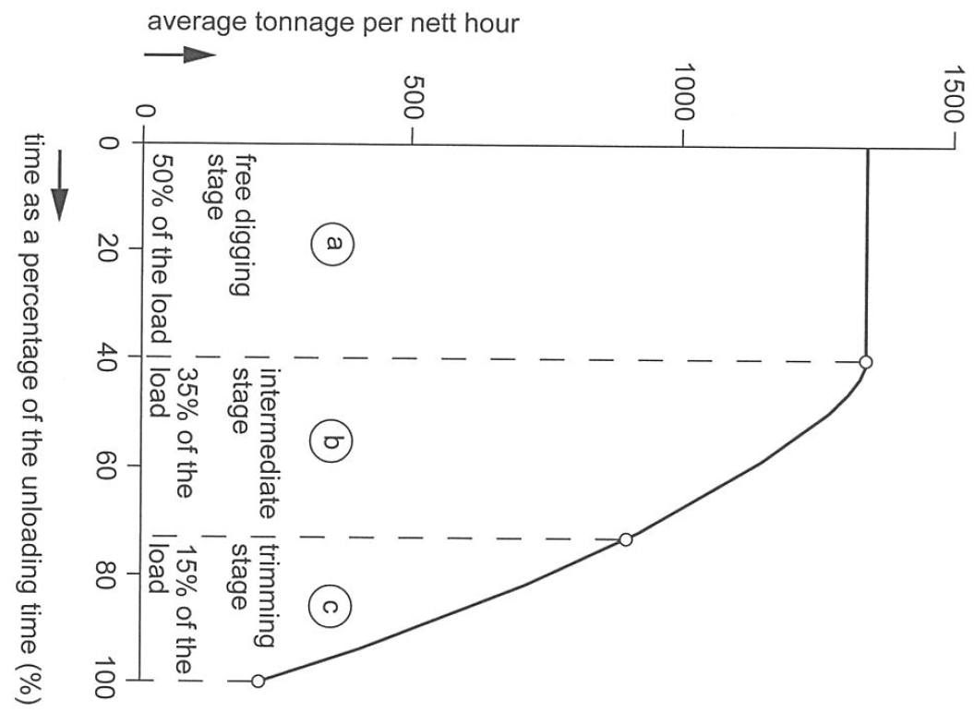

Figure 3.5: Various stages within the unloading procedure

Cranes equipped with grabs are the most commonly used method to unload dry bulk vessels for bulk cargo’s, as they can handle a wide range of commodities12. When handling free-flowing commodities such as agribulk, the traditional clamshell bucket has proven to be the most cost-effective grab mechanism (**see figure X**)43.

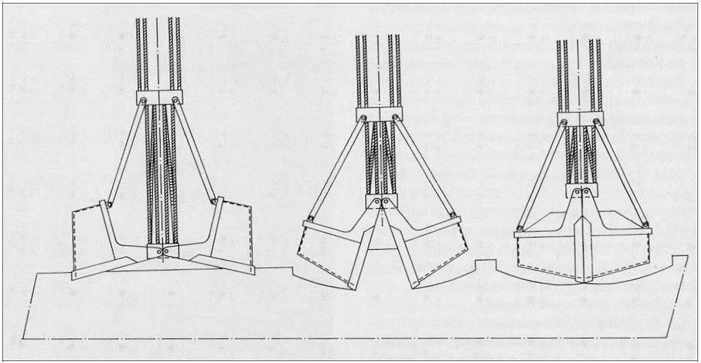

Figure 3.6: Clamshell mechanics 44

Grabs are used on gantry cranes, harbour cranes and mobile harbor cranes among others45. The unloading capacity of such a crane is based on two components; the grab capacity of a crane and the speed at which a crane completes an unloading cycle.

Consulting grab producers and analyzing the loadout of cranes on existing terminals has shown that there is a linear correlation between a crane’s *lifting capacity* and the corresponding *grab payload* (i.e. the amount of cargo lifted with one grab cycle) regardless of the type of crane or the type of commodity being handled (**see figure X**)46,47. The only anomalies are related to the handling of wood pellets due to their very low volumetric density (400 – 450 kg/m3). By excluding the data related to wood pellet terminals, the required lifting capacity of a crane ($W_{lift}$) can be correlated to the cranes grab payload ($W_{payload}$) through the following expression:

|  |  |
| --- | --- |
| $$W_{payload}=\frac{W_{lift}-2.4}{1.4}$$ | Eq. xx |

Figure 3.7: Empirical crane data46,47

The speed at which cranes can complete an unloading cycle is largely dependent on the type of crane being used. The following sections will zoom in on the three types of grab cranes that fall within the scope of this research.

* + 1. Gantry cranes

Gantry grabs allow the clamshell bucket to travel over an overhead boom and discharge the load in a dedicated hopper (see **figure x**), offering the fastest handling time of all the cranes that can be equipped with grabs.

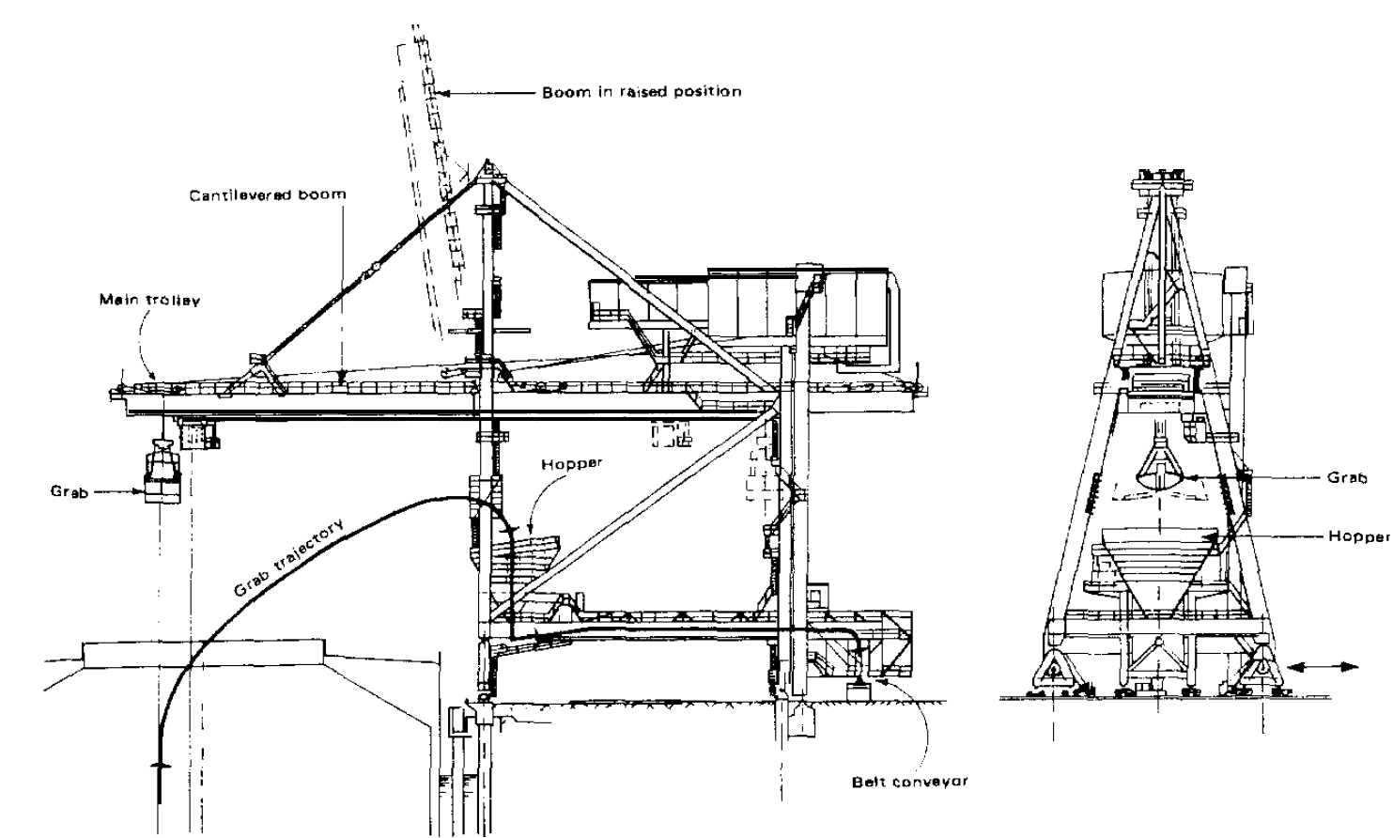

Figure 3.8: Gantry crane 40

Unloading rate

Large gantry grabs are normally semi-automated. The crane driver, sitting in a movable, but stationary cabin, digs in the grab with the help of the controllers. After having hoisted the grab up to a certain position, a knob is pushed which starts the automation. The grab automatically runs towards the hopper, opens, discharges the material, and automatically returns to the point where the crane driver started the automation. The crane driver then takes command again and lowers the grab further to fill it. As many as 80 cycles per hour can be achieved using such technology40. However, as this only applies to a high-end selection of crane models, the number of cycles per hour ($n_{c}$) is set to 60 within the computer model40,43,46,48. When combined with **equation xx,** this results in the following correlation between a crane’s lifting capacity ($W_{lift}$), the *effective capacity index* ($γ_{eff}$) and the resulting peak unloading capacity ($P_{peak}$) and effective unloading capacity ($P_{eff}$):

|  |  |  |  |  |  |
| --- | --- | --- | --- | --- | --- |
| $$P_{peak}$$ | $$=$$ | $$n_{c}∙\frac{W_{lift}-2.4}{1.4}$$ | $$in which$$ | $$n_{c}=60$$ | Eq. xx |
| $$P_{eff}$$ | $$=$$ | $$n_{c}∙\frac{W_{lift}-2.4}{1.4}∙γ_{eff}$$ | $$in which$$ | $$n_{c}=60$$ $$γ_{eff}=0.4$$ | Eq. xx |

CAPEX – *Unit rate and mobilisation costs*

The financial data for cranes is hard to come by and the CAPEX findings are based on two cases; a MTBS project in 2015 and the upcoming delivery of new cranes to a terminal here in the Netherlands. Based on MTBS expertise, both purchases are assumed to include $100.000 transport costs (i.e. mobilization costs). The cost efficiency of both cranes has been averaged to come to the crude assumption that gantry cranes cost $5650 per th-1 of peak capacity. All values are noted in current US$.

CAPEX – *Mobilisation costs*

The mobilisation cost is assumed to be $100.000, irrespective of the size of the crane. This is assumption is based on project experience within MTBS.

CAPEX – *Time until delivery*

Within the model it is assumed that it takes one year for gantry cranes to come online after purchasing, irrespective of the amount of cranes that have been purchased.

|  |  |  |  |  |  |
| --- | --- | --- | --- | --- | --- |
| CAPEX | Total purchase | Unit rate | Mobilization | Peak capacity | Cost efficiency |
| Crane 1 | $18.4M | $18.3M | $0.1M | 1870 t/h | 5214 $/t/h |
| Crane 2 | $9.85M | $9.75M | $0.1M | 3000 t/h | 6100 $/t/h |

OPEX – *Maintenance*

Based on correspondence with an internation container terminal operator, 2% of the purchase cost of a gantry crane should be reserved for yearly maintenance. This research assumes that the durability of gantry cranes used for container handling are similar to that of gantry cranes used at dry bulk terminals.

OPEX – *Labour*

Based on a single dry bulk project in Africa, this research assumes that gantry crane operations requires a crew of three operational staff.

OPEX – *Energy*

The conclusions of a study on gantry cranes used at coal terminals stipulate that the energy consumption of a grantry crane, in kWh, can be approximated as 30% of its peak capacity, denoted in tons per hour.

OPEX – *Insurance*

It is standard practice to insure the assets on a terminal. Based on expertise within MTBS, this research assumes that 1% of an asset’s initial investment is reserved as yearly insurance.

OPEX – *Reinvestment*

When an asset reaches the end of its lifespan, it is assumed that it requires a full re-investment, either because it is at risk of collapsing or because maintenance works become increasingly costly as assets become older. Although the three gantry cranes situated at the TATA Steel terminal in the Netherlands were delivered in 1966, it is common practice to assume that gantry cranes have a lifespan of 40 years.

* + 1. Radial cranes

Radial grabs, or revolving grabbing cranes, are the most commonly used type of crane used for unloading. The crane lifts the material and discharges it into a hopper on the quay. Due to the the required rotating motion, the grab cycle costs more time than the gantry cranes. The UNCTAD report45, dating from 1985, concludes that conventional handling rates are in the order of 20 cycles an hour. However, after consultation with various terminal operators31,42,48, this figure is set to 40 cycles an hour within the computer model. This discrepancy may well be the result of the improved crane manuafracturing over the past 30 years (e.g. improved winch speeds, improved radial engines etc.). The resulting unloading capacity of a radial crane can be calculated using equation xx.

|  |  |  |  |  |  |
| --- | --- | --- | --- | --- | --- |
| $$P_{peak}$$ | $$=$$ | $$n_{c}∙\frac{W_{lift}-2.4}{1.4}$$ | $$in which$$ | $$n_{c}=40$$ | Eq. xx |
| $$P_{eff}$$ | $$=$$ | $$n_{c}∙\frac{W_{lift}-2.4}{1.4}∙γ_{eff}$$ | $$in which$$ | $$n_{c}=40$$ $$γ_{eff}=0.4$$ | Eq. xx |

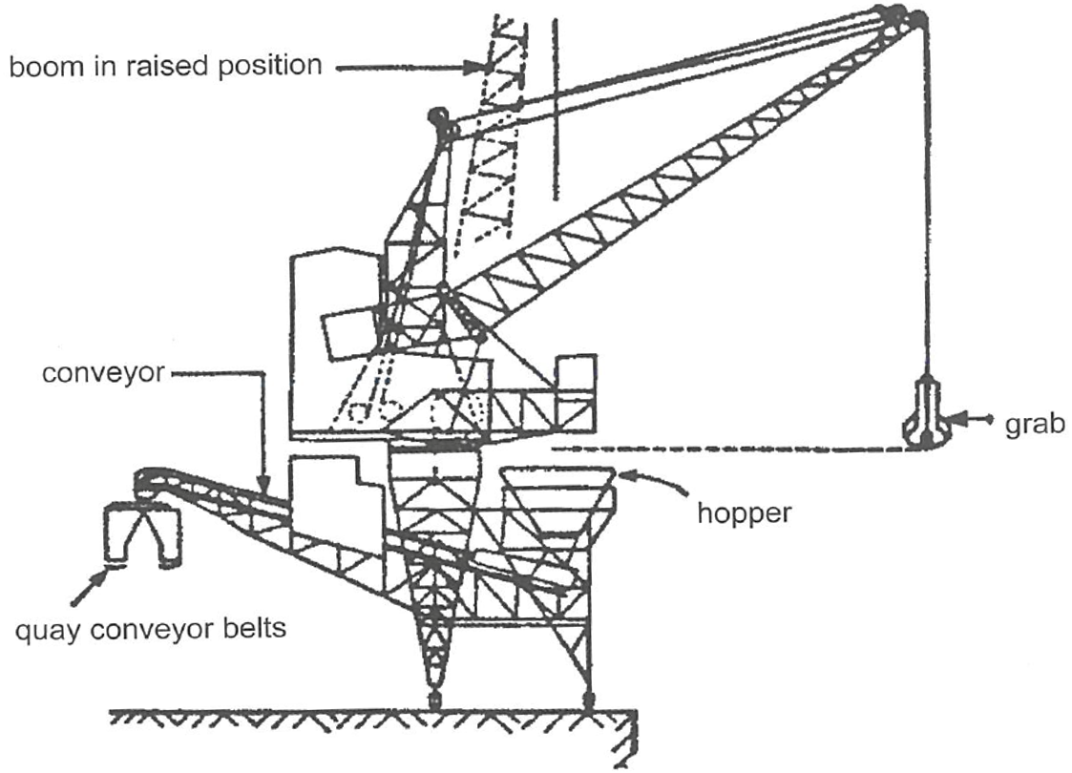

Figure 3.9: Radial crane 40

CAPEX – *Unit rate*

Within the model it is assumed that it takes two years for a quay to become useable after purchasing, irrespective of the length of quay that is to be built.

CAPEX – *Mobilisation costs*

Within the model it is assumed that it takes two years for a quay to become useable after purchasing, irrespective of the length of quay that is to be built.

CAPEX – *Time until delivery*

Within the model it is assumed that it takes two years for a quay to become useable after purchasing, irrespective of the length of quay that is to be built.

OPEX – *Maintenance*

In order to guarantee asset

OPEX – *Labour*

In order to guarantee asset

OPEX – *Energy*

In order to guarantee asset

OPEX – *Insurance*

In order to guarantee asset

OPEX – *Reinvestment*

* + 1. Mobile Harbour Cranes

The mobile harbor cranes are essentially harbor cranes that have been put on wheels or tracks. The extendable tower structure allow the operator to view the hold during operations. Handling rates are a bit smaller than radial harbor cranes, resulting in approximately 30 cycles an hour. However, movement between holds takes longer than rail mounted radial cranes, as mobile harbor cranes have to resposition the operator cabin and lift and lower their outriggers at each move. The *effective capacity index* has therefore assumed to be 0.35, slightly lower that of the other cranes equipped with grabs. The resulting correlation between a crane’s lifting capacity and its peak and effective unloading capacity is given below:

|  |  |  |  |  |  |
| --- | --- | --- | --- | --- | --- |
| $$P_{peak}$$ | $$=$$ | $$n_{c}∙\frac{W_{lift}-2.4}{1.4}$$ | $$in which$$ | $$n_{c}=30$$ | Eq. xx |
| $$P_{eff}$$ | $$=$$ | $$n_{c}∙\frac{W_{lift}-2.4}{1.4}∙γ_{eff}$$ | $$in which$$ | $$n_{c}=30$$ $$γ_{eff}=0.35$$ | Eq. xx |

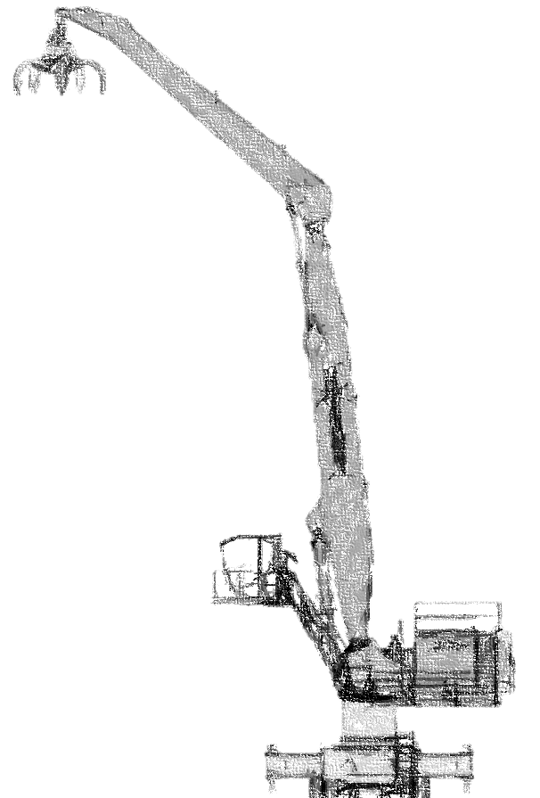

Figure 3.10: Mobile harbour crane

CAPEX – *Unit rate*

Within the model it is assumed that it takes two years for a quay to become useable after purchasing, irrespective of the length of quay that is to be built.

CAPEX – *Mobilisation costs*

Within the model it is assumed that it takes two years for a quay to become useable after purchasing, irrespective of the length of quay that is to be built.

CAPEX – *Time until delivery*

Within the model it is assumed that it takes two years for a quay to become useable after purchasing, irrespective of the length of quay that is to be built.

OPEX – *Maintenance*

In order to guarantee asset

OPEX – *Labour*

In order to guarantee asset

OPEX – *Energy*

In order to guarantee asset

OPEX – *Insurance*

In order to guarantee asset

OPEX – *Reinvestment*

asdasdasd

* + 1. Vertical Screw Unloaders

Vertical screw unloaders unload a vessel by transporting cargo to a slewing boom through a large vertical screw system. The elevator system may be steered to improve access into the wings of the hold, reducing the time needed to trim the hold. The literature study into the capacity of these types of ship unloaders provides a wide range of unloading capacities. UNCTAD, dated from 1985, describes a maximum capacity of 600 t/h 45, but as those findings seem a bit outdated the technical characteristics have been based on interviews with terminal operators and communication with Siwertell, a manufacturer of screw unloaders based in Sweden.

At one of the major soybean import terminals in the Netherlands, the unloading of vessels is done through a single berth equipped with two screw unloaders. Each unloader has a peak capacity of 700 t/h, but empirical data shows that on average each screw unloader unloades at roughly 400 t/h due to low productivity during the trimming phase31. The *effective capacity* *index* of screw unloaders has therefore been set to 0.58 within the computer model, bringing them in line with these findings.

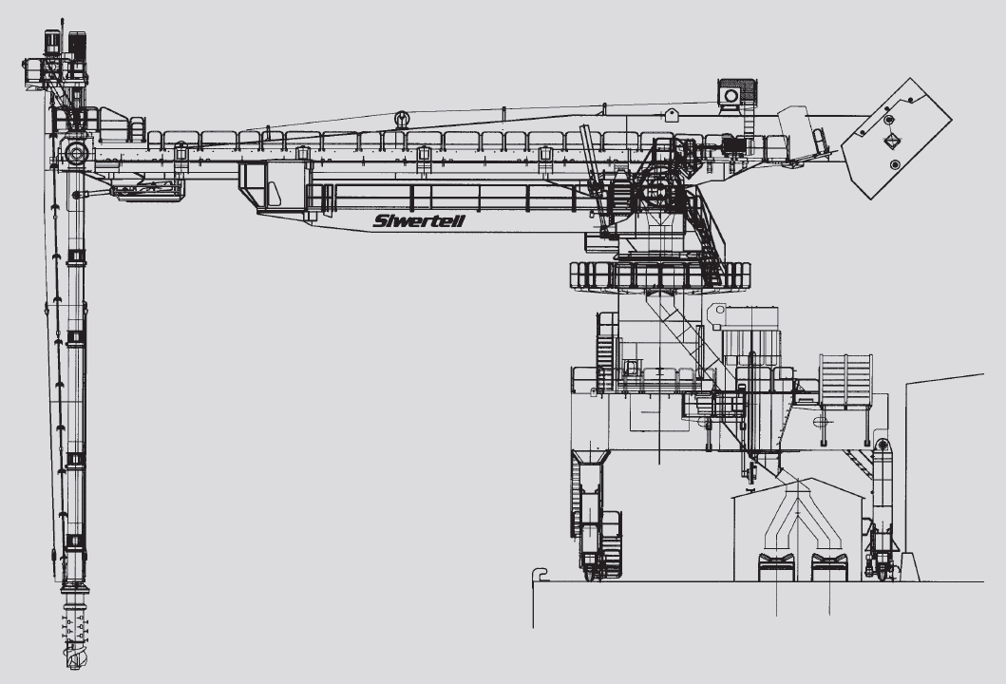

Figure 3.11: Siwertell screw unloader

|  |  |  |  |  |
| --- | --- | --- | --- | --- |
|  | $$P_{eff}=P_{peak}∙γ_{eff}$$ | $$in which$$ | $$γ_{eff}=0.58$$ | Eq. xx |

CAPEX – *Unit rate*

Within the model it is assumed that it takes two years for a quay to become useable after purchasing, irrespective of the length of quay that is to be built.

CAPEX – *Mobilisation costs*

Within the model it is assumed that it takes two years for a quay to become useable after purchasing, irrespective of the length of quay that is to be built.

CAPEX – *Time until delivery*

Within the model it is assumed that it takes two years for a quay to become useable after purchasing, irrespective of the length of quay that is to be built.

OPEX – *Maintenance*

In order to guarantee asset

OPEX – *Labour*

In order to guarantee asset

OPEX – *Energy*

In order to guarantee asset

OPEX – *Insurance*

In order to guarantee asset

OPEX – *Reinvestment*

|  |  |  |  |  |  |
| --- | --- | --- | --- | --- | --- |
| Terminal | Peak t/h | Rated t/h | Effective t/h | Weight (t) | Width (m) |
| Bunge | 700 | 450 |  |  |  |
| \*Unknown\* in Liverpool (transported by BigLift) | 1200 |  |  | 560 | 24 |

In order to provide an accurate assessment, unloading rates have been benchmarked using a range of vertical screw conveyors currently utilized by dry bulk terminals. Further information was provided by one of the global leading producers of vertical screw unloaders based in Sweden, Siwertell. **Figure x** visualizes how the *free-digging rate* of vertical screw excavators lies between 400 and 1950 [m3/h].

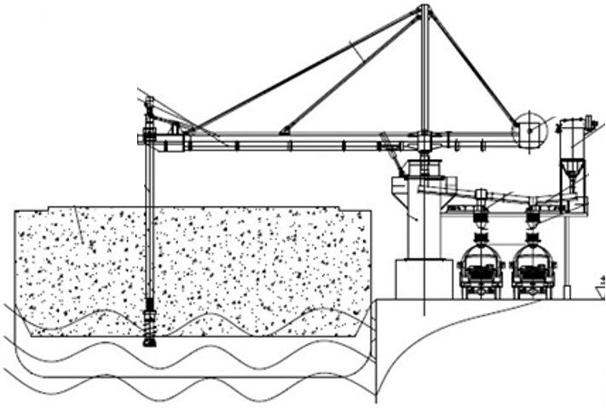

Figure 3.12: Vertical screw ship unloaders

|  |  |
| --- | --- |
| Source | Production |
| 45 | 250 t/h (revolving) |
|  |  |
|  |  |
|  |  |

|  |  |  |  |
| --- | --- | --- | --- |
| Crane type | Cycles per hour | Peak capacity | Effective Capacity Index |
| Gantry grabs | 60 | $\frac{C_{crane}-2.41}{1.404}$ per cycle | 1.0 |
| Level-huffing grabs | 40 | $\frac{C_{crane}-2.41}{1.404}$ per cycle | 1.0 |
| Radial grabs | 20 | $\frac{C_{crane}-2.41}{1.404}$ per cycle | 1.0 |
| Mobile harbor crane | 20 | $\frac{C_{crane}-2.41}{1.404}$ per cycle | 0.9 |
| Vertical screw conveyor | - | Max 2400 t/h (coal) | 1.2 |
| Bucket Elevator | - | Max 5000 t/h (coal) | 1.2 |

Asdasd

* + 1. Design assumptions

There are four technical characteristics that play a role when designing a quay wall in an early design phase; a quay wall’s required freeboard, its retaining height, the number of berths and the resulting length of the quay.

* Unloading capacity (peak vs. effective data van TATA)
  + 1. Financial characteristics

**Capital expenditures**

* Unit cost
* Mobilisation cost (expert assumtion)
* Construction time

**Operational expenditures**

* Maintenance
* Labour
* Energy
* Insurance
* Reinvestments (lifespan)
  + 1. Conventional design rules
* The design rules are interlocked with those of the quay through the required number of berths
* Effective capacity influences service times

#### 

#### Terminal elements - Storage facilitites

Asdasd

* + 1. Technical characteristics
* Storage capacity
  + 1. Financial characteristics

**Capital expenditures**

* Unit cost (Bunge, Cargill)
* Mobilisation cost (percentage?)
* Construction time

**Operational expenditures**

* Maintenance
* Labour (silo vs warehouse)
* Energy
* Insurance
* Reïnvestments (lifespan)
  + 1. Conventional design rules
* Percentage of annual throughput
* Peak factor

#### Terminal elements - Hinterland loading facilitites

Asdasd

* + 1. Technical characteristics
* Loading capacity
  + 1. Financial characteristics

**Capital expenditures**

* Unit cost (Oekraine projects)
* Mobilisation cost (percentage?)
* Construction time (assumption?)

**Operational expenditures**

* Maintenance
* Labour
* Energy
* Insurance
* Reïnvestments (lifespan)
  + 1. Conventional design rules
* Simililar apporach to arriving vessels (Erlang distribution for service rate and arrival time and nr of berths)
* Allowable waiting factor for trains/trucks
* Met Ryan overleggen for example projects

#### Terminal elements - Conveyors

Asdasd

* + 1. Technical characteristics
* Length
* Capacity
  + 1. Financial characteristics

**Capital expenditures**

* Unit cost (project data and expertise judgement)
* Mobilisation cost (?)
* Construction time

**Operational expenditures**

* Maintenance
* Labour
* Energy
* Insurance
* Reinvestments (lifespan)
  + 1. Conventional design rules
* Length 🡪 Model input parameter (depending on terminal layout
* Capacity (quay) 🡪 Summated peak unloading capacity of quay equipment (Bunge setup)
* Capacity (hinterland) 🡪 summated peak loading capacity of hinterland loading dock

* + 1. Terminal storage

Introduction

* + 1. Storage Requirements
    2. Silo Storage

An alternative to covered storage, for free flowing, dry cargoes such as grain and animal

feed where protection is required not only against the weather but also against vermin, or

cargos such as cement where the material is particularly dusty, vertical silos can be used.

These are typically vertical circular silos arranged in multiple units and fed via conveyor to

the top of the silos and reclaimed from the base of the silos direct to a bagging plant, road

truck or rail wagon. Material is usually withdrawn from the silos by variable speed feeder

conveyors and may be directed onto other conveyors for transport to a ship loader or a

process plant. Cement and other fine dusty cargo is usually pumped into the silos and

withdrawn through pipes also.

12

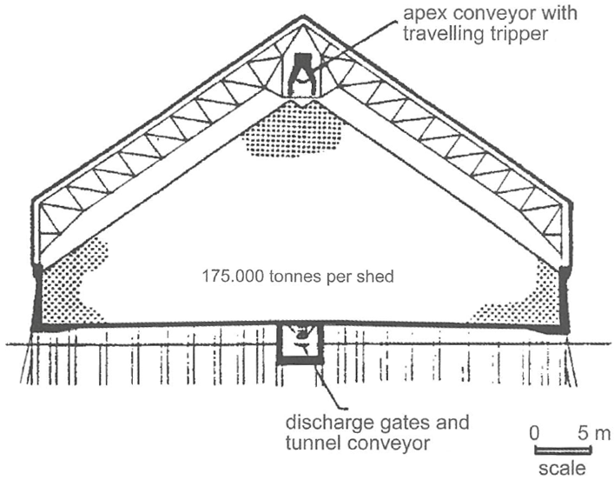

* + 1. Covered Storage

Bulk cargoes which require protection from the weather, or themselves pose significant

environmental risks require covered storage, normally a conventional portal framed

structure with the material being fed into the store via overhead conveyors with travelling

trippers and reclaimed by means of rail mounted travelling portal scraper reclaimers or

mobile plant. Some covered storage is in the form of geodesic dome structures that feature circular stackers and scraper reclaimers. 12

* + 1. Open Storage

**Terminal landside interface**

Model split?

For export terminals the delivery of bulk cargo to the export stockpile may be by rail, road

or some form of fixed conveying system such as overhead bucket conveyors. The most

usual method is by rail, with wagons emptied either by:

• Bottom discharge to an underground hopper feeding belt conveyors

• Rotary tipping to an underground hopper feeding belt conveyors

• End tipping to an underground hopper feeding belt conveyors

• Pneumatic discharge in the case of products such as cement in bulk

Discharge of road going vehicles is similar, but generally the vehicles are self-discharging,

i.e. tipper trucks, and frequently discharge to mobile hoppers to be carried by conveyor to

stockpiles/silos or to the feed hopper of mobile shiploaders for direct ship loading.

Similar considerations apply to import terminals, where the delivery of the bulk cargo, either

from the terminal stockyard or from the quayside, to the final destination may be by road,

rail, conveyor or a combination of these. For transfer to road or rail transport it may first be

necessary to reclaim materials from the stockpiles and transfer it to road or rail loading silos,

unless direct loading to the transport is contemplated. Direct loading operations of this sort

using mobile plant are inevitably less efficient and less environmentally acceptable, but may

provide the lowest overall cost solution. 12

* + 1. Ship Loading Equipment

Ship loading systems are relatively simple compared with unloading systems, since

generally only a simple feed conveyor and chute are needed to load the vessel. The

shiploaders are normally positioned adjacent to the hatch to be loaded and receive the

material via belt conveyors from the stockpile. These feed a loading boom which projects

from the berth face over the hold. Shiploaders with boom conveyors fall into three distinct

categories 12:

**Rail Mounted Travelling Loaders** that move along the length of the vessel and are fed

from the loading pier conveyor up an inclined tripper section that lifts the conveyor to the

transfer point on the boom conveyor. These fall into two further sub categories that provide

the variable outreach:

• **Slewing Loaders** where a fixed length boom may be slewed into position, in

combination with long travel movements to reach all points of the hatch opening.

• **Boom Conveyor Shuttle Systems** that enable the discharge pulley of the loading

conveyor to move perpendicular to the beam of the vessel. The combination of shuttle

movement and long travelling provides the full hatch coverage required.

**Single or Dual Quadrant Loaders** that have one or two loading booms with a fixed pivot

point at the landward end. The outer end of the boom(s) travel in an arc on rails and a

shuttle system on the boom provides full hatch coverage.

**Dual Linear Shiploaders** where the waterside end of the loading boom travels on short

rails parallel with the length of the vessel and the landward end of the loading boom moves

at right angles to the berthing line. Full hatch coverage is again provided by a shuttle system.

All three types should also incorporate a luffing motion to accommodate tidal changes and

the changing draught of the vessel as it is loaded.

Currently the highest rated shiploaders in service loading iron ore range from 16-18,000 tonnes per hour. The effective loading rates are heavily influenced by the performance of the equipment used to reclaim material from the stockpiles – usually bucket wheel reclaimers in the case of coal and iron ore. 12

**Environmental aspects**

20



Safety zones

Dust hazard

**Terminal example**

????

**Terminal Capacity**

12????

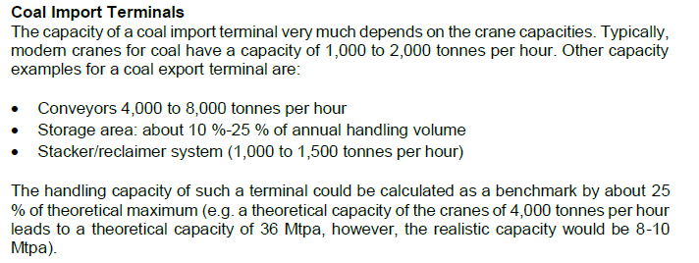

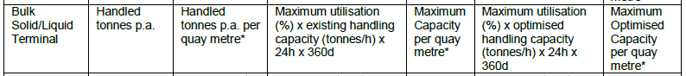

## Terminal Modelling

This chapter will start off with an introduction to terminal modelling together with an overview of existing terminal models that have been developed as a result of previous research into the terminal optimization. The subsequent sections will build on the findings presented in the previous chapter, in which an overview of all the terminal elements that fall within the scope of this research was given, by clarifying how each component is represented within the developed dicision support tool. Similar to the previous chapter, each element will have its own dedicated section in which previous modelling approaches regarding that specific element will be presented, before concluding by showing the modelling approach that has been applied in this research.

#### Existing terminal models

20

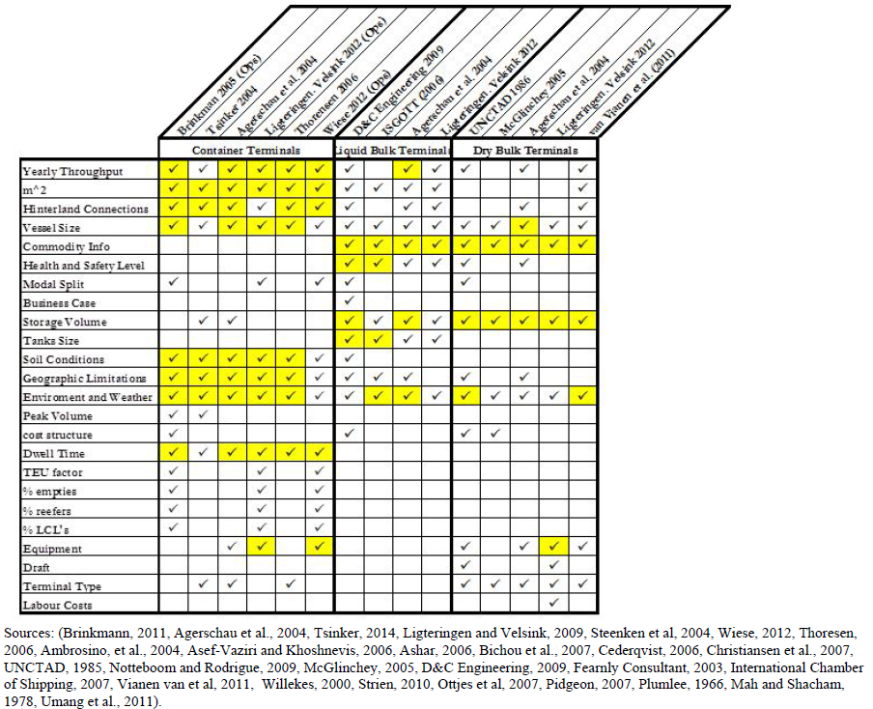

#### Modelling - Quay wall

Asdasd

* + 1. Existing modelling approaches

Possible addition:

1. Flow chart of each element how a investment decision is made

Modelling quay requirements is an important component in terminal optimization, as quays often represent a substantial portion of the overall capital investments required in terminal development. The required dimensions of the quay are dictated by the requirements of the individual berths located at the terminal. Extensive research into berth allocation has been conducted, be it that the majority of the papers focused on the container sector. All in all, the modelling of berth requirements can roughly be divided into three methods49,50:

|  |  |  |  |
| --- | --- | --- | --- |
| Discrete quay layout | *Figure xx.a* |  | The quay is divided into berths and each berth can only serve one vessel at a time. |
| Continuous quay layout | ***Figure xx.b*** |  | Berths have no spacial constraints and vessels can berth anywhere along the quay if there is sufficient room. |
| Hybrid quay layout | ***Figure xx.c*** |  | The quay is divided into berths, but large vessels can occupy more than one berth. |

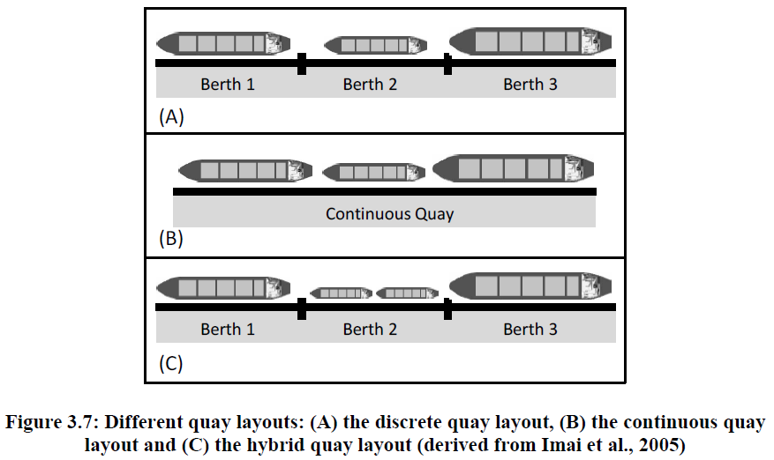

Figure 4.1: Different quay layouts. a) discrete layout b) coninuous layout c) hybrid layout

Within the computer tool the characteristics of the quay wall have been quantified through the following set of parameters:

* + Number of berths
  + Length
  + Depth
  + Freeboard
  + Lifespan
  + Costs ($65000/m (11m) and $80.000/m (15m) in Ondo

Modeling the seaside operation is essential for realizing realistic quay designs. Compared to the significant amount of research on the transshipment of containers at container terminals, a limited number of papers discussed the seaside operation at dry bulk terminals. The seaside modeling of container terminals will be investigated to find possible analogies that can be applied to dry bulk terminals. Comprehensive overviews on applications and optimization models for the operations management in container terminals were given by Vis and De Koster (2003), Stahlbock and Voβ (2008) and Bierwirth and Meisel (2010). Several sub problems were distinguished; the assignment of ships to berthing locations alongside the quay (the berth allocation problem), the assignment of cranes to ships (the quay crane assignment problem) and the determination of cranes operating plans (the quay crane scheduling problem). Sections 3.3.1 until 3.3.3 review the literature available for these sub problems and section 3.3.4 evaluates this survey and indicates the approach used in this chapter.

**3.3.1 Berth Allocation Problem**

The berth allocation problem covers the mooring of a set of ships within the boundaries of the quay and within the planning horizon. For each ship additional data like the ship’s length, its draft, the expected time of arrival, and the projected handling time must be given. Several spatial constraints restrict the feasible berthing positions according to a preset partitioning of the quay into berths.

According to Imai et al. (2005) the following layouts can be recognized:

• Discrete quay layout (Figure 3.7A): the quay is divided into a number of berths and only one vessel can be served at each single berth. Either the quay construction causes the partitioning into berths or berths are applied to ease the planning problem.

• Continuous quay layout (Figure 3.7B): the quay has no spatial constraints and vessels can berth at arbitrary positions. Berth planning is more complicated but the quay can better be utilized.

• Hybrid quay layout (Figure 3.7C): the quay is partitioned into berths but large vessels may occupy more than one berth and small vessels may share a berth.

Han et al. (2006) and Zhou et al. (2006) included spatial constraints into their models to ensure that ships are moored at positions with sufficient water depth. Many models were developed to minimize the sum of the ships waiting and handling times. Schonfeld and Frank (1984) employed analytical models, Lai and Shih (1992), Legato and Mazza (2001 and 2013), Henesey et al. (2004) and Canonaco et al. (2008) developed simulation models and Dragovic et al. (2006) developed an analytical model based on queuing theory. 30 Simulation-integrated design of dry bulk terminals

Many authors suggested the First-Come-First-Served (FCFS) method to determine the ship service order; Lai and Shih (1992), Botter et al. (2005), Singh et al. (2010), Hartmann et al. (2011) and Umang et al. (2013). The Earliest-Due-Date (EDD) method when ships with the earliest due date for completion are firstly berthed was suggested by Lai and Shih (1992) and Hartmann et al. (2011). Barros et al. (2011) proposed a high demurrage ship algorithm for the ship service order. The demurrage cost for each arrived ship must be calculated. The total terminal cost can then be minimized by serving high-cost ships earlier than low-cost ones.

Umang et al. (2013) and Robenek et al. (2013) studied the berth allocation problem explicitly for bulk ports by taking the cargo type (liquid bulk and dry bulk) into account. Conveyors or pipelines have to be selected for the transport of cargo between the seaside and predefined stockyard locations. In both papers it was assumed that the entire shipload was stored at one location. The authors stated that solving the problem for multiple storage locations per ship would be complicated. Two exact methods based on mixed integer linear programming were proposed. Heuristic approaches based on squeaky wheel optimization (Umang et al., 2013) and critical-shaking neighborhood search (Robenek et al., 2013) were applied to solve the problem in large scale environments.

* + 1. Applied modelling approach

Asdasd

As this research only covers agribulk terminals, the discrete quay layout has been applied within the computer tool. This is justified by the fact that horizontal transport on the terminal is done by fixed conveyors, which require fixed berthing locations. Furthermore, it has been assumed that each berth is big enough to accommodate every type of vessel that calls at the terminal. This simplification may lead to a slight overdimensioning of the quay walls, but as the lengths of the vessels that are incorporated within the model do not show very large differences (i.e 170m – 225m) this simplification is deemed reasonable.

Erlang distribution shown in **figure xx**, has been translated into a continuous mathematical formulation through polynomial regression, before being applied within the terminal model.

#### Modelling - Unloading equipment

Asdasd

* + 1. Existing modelling approaches

Asdasd

* + 1. Applied modelling approach

Asdasd

#### Modelling - Conveyors

Asdasd

* + 1. Existing modelling approaches

Asdasd

* + 1. Applied modelling approach

Asdasd

#### Modelling - Storage facilitites

Asdasd

* + 1. Existing modelling approaches

Asdasd

* + 1. Applied modelling approach

Asdasd

#### Modelling - Hinterland loading facilitites

Asdasd

* + 1. Existing modelling approaches

Asdasd

* + 1. Applied modelling approach

Asdasd

# The Terminal Model



## The Terminal Model

Introduction

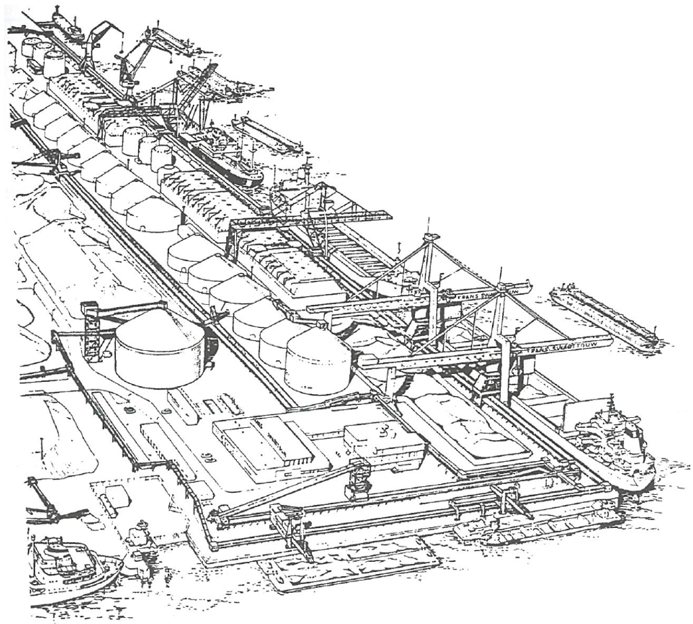

A distinct feature of optimization programming in general is the exponential relationship between the number of optimization variables and the model’s computational requirements. It is therefore useful to conduct a preliminary sensitivity analysis on the impact of different terminal elements on the overall lifetime cost of a project. The goal of the sensitivity analysis is to determine what elements should essentially be included in the optimization algorithm (i.e. the elements that have a large impact on overall terminal life-cycle costs). Once the capital-intensive elements have been optimized, the remaining terminal elements will be geared to meet hourly unloading capacity.

#### Modelling objective

Asdasd

#### Key performance indicators

Net present value

Source: Van Gijt37

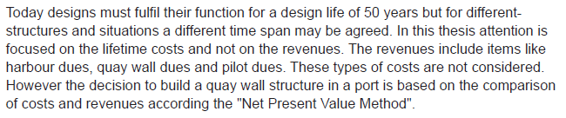

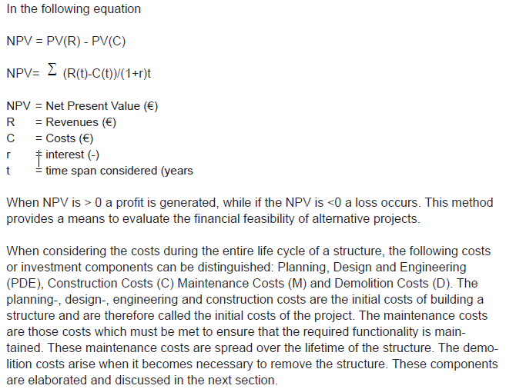

#### Model structure

Responsive vs predictive

* + 1. Model input

Based on economic scenario’s

* + 1. Model output

Invrestment trigger optimimalisation

#### International applicability

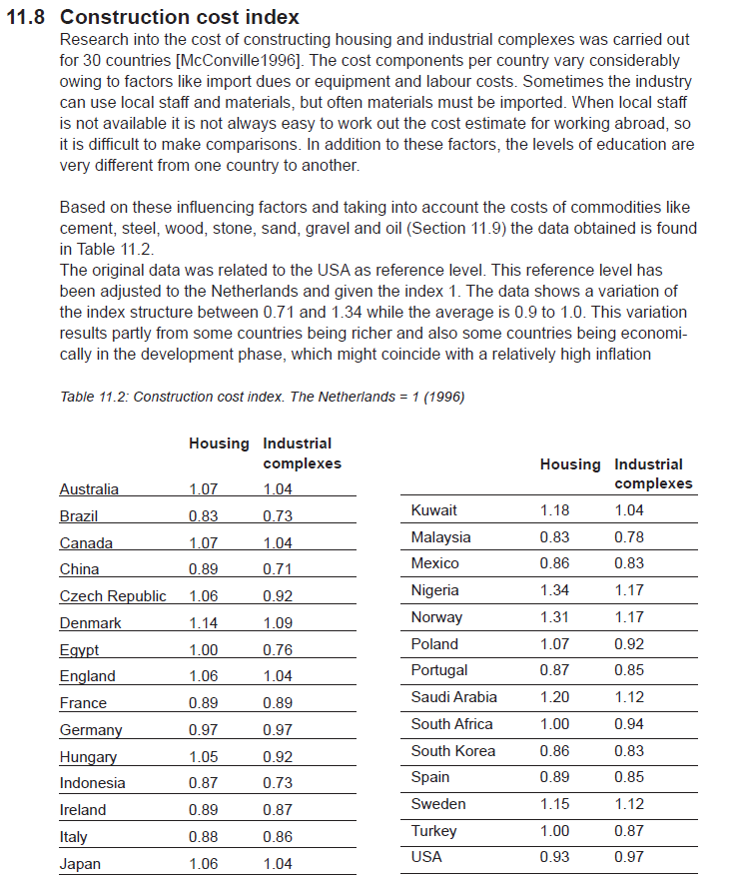

#### Triggering investments within the simulation

* + 1. Literature review

Berth allocation problem

Quay crane assignment problem

Evalutation of modelling approaches

#### Significant factors for terminal design

#### Increasing terminal flexibility

Asdasd

## Making Traffic Projections

Introduction

“The further you look ahead, the less you see. You can still look far ahead, but then you have have peace with the fact that this results in a lower level of detail. This is an inevitable tradeoff. ”

“As profit margings become every more critical within the bulk-handling sector, innovative methods of maximizing terminal value through minimal costs becomes every more important. This work sets out to do so by including trend analysis in order to predict future traffic flows and effectively integrate them into investment decisions within the terminal.”

* The tool can simulate strategic decision making by incorporating a year-to-year forecasting technique on which investment decisions are based.
* In doing so, triggers leading up to investment decisions can be evaluated and corss-examined with conventional rules of thumb within current literature.

#### Traffic scenario’s

sdfasdf

**“The proposed forecast methodology**

At the start of this PhD project a method for developing probabilistic very long term transport forecasts with a time span of almost 100 years did not yet exist. I have therefore developed a new probabilistic forecast method that is based on the existence of a strong causal relation between economic output and transport. This new method contains the following three steps: (1) apply system dynamics modelling to obtain a probabilistic forecast of the total- and working age population in the Region; (2) apply judgement to make probabilistic assumptions on the development of labour participation, annual working hours, and GDP output per worker – and use these assumptions to convert the probabilistic estimates of the working age population into a probabilistic GDP forecast for the Region; and (3) apply the causal GDP-transport relation to obtain a probabilistic transport forecast for the Region.”

“However, the simultaneous upward movement of two trending time series does not necessarily imply that a real causal relation between these two variables exists. To make sure that the GDP-transport relation is real I studied the special case of Lithuania, for which the economy has been growing until the dissolution of the USSR in 1989, showed a decline thereafter, and recovered from 1995 onwards. The data for Lithuania showed a simultaneous movement of the GDP and transport variables along an up- and downward trend and therefore ‘proved’ that the causal relation between GDP and transport is real – and if this holds for the single country of Lithuania it is also likely to hold in general (see Figure 7-2).”

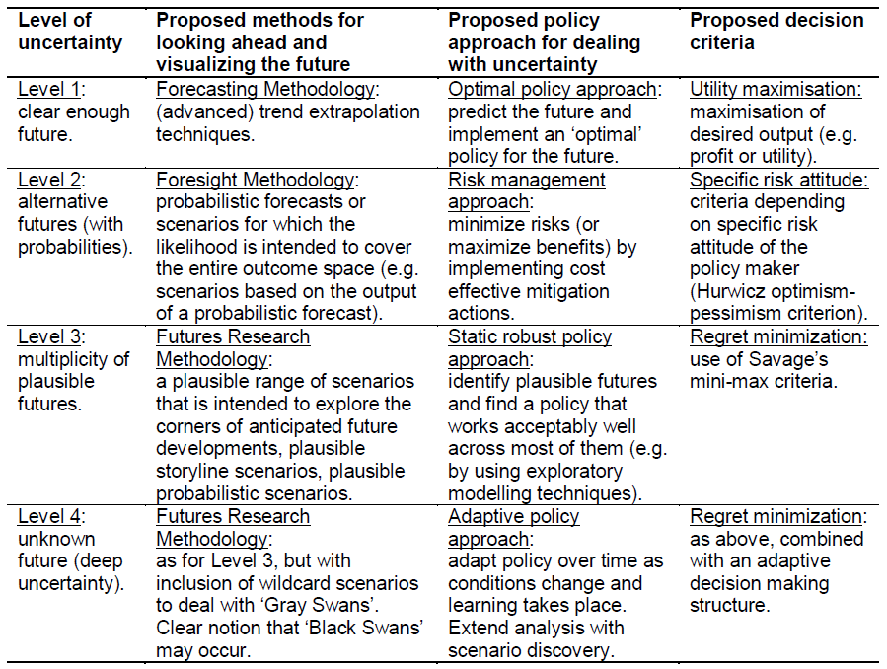

#### Traffic forecasting

Scenario’s developed for the investment simulator based on UN population growth, and GDP per capita development. Includes erratic

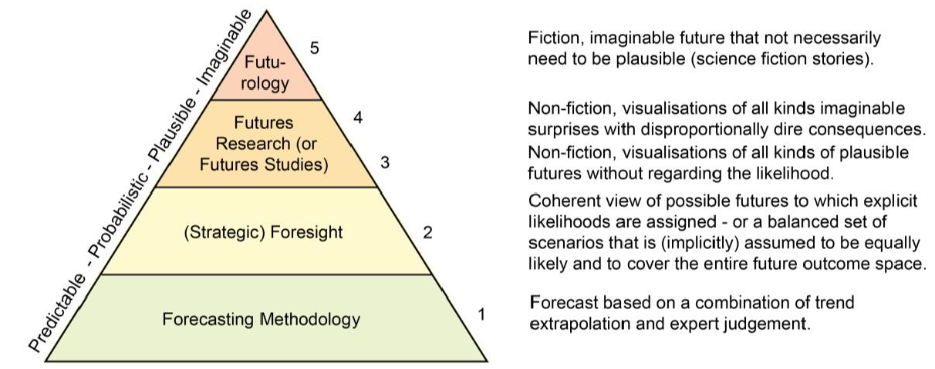

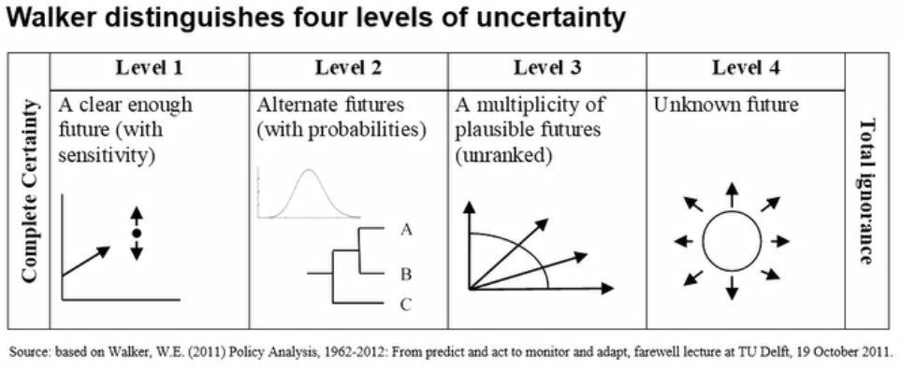

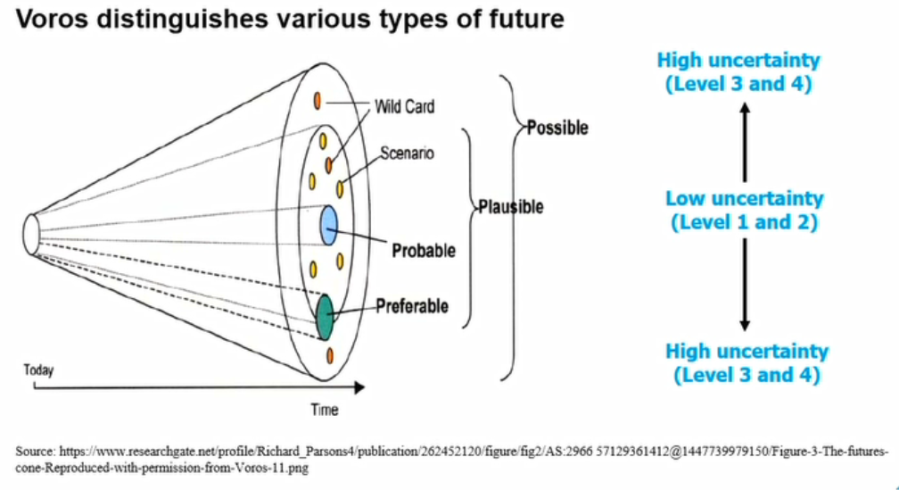

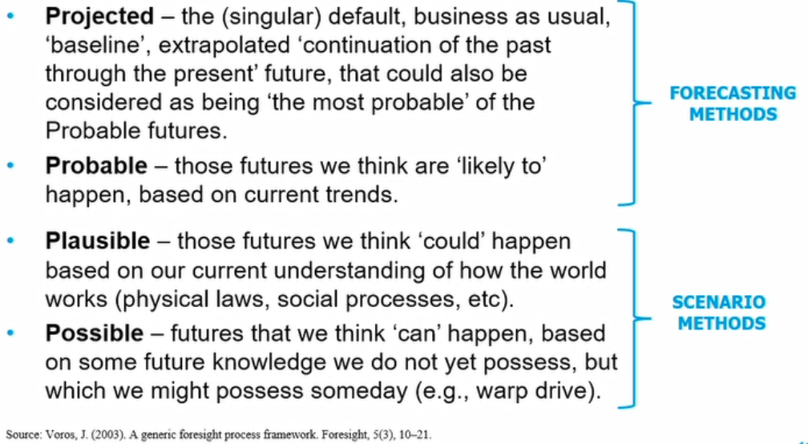

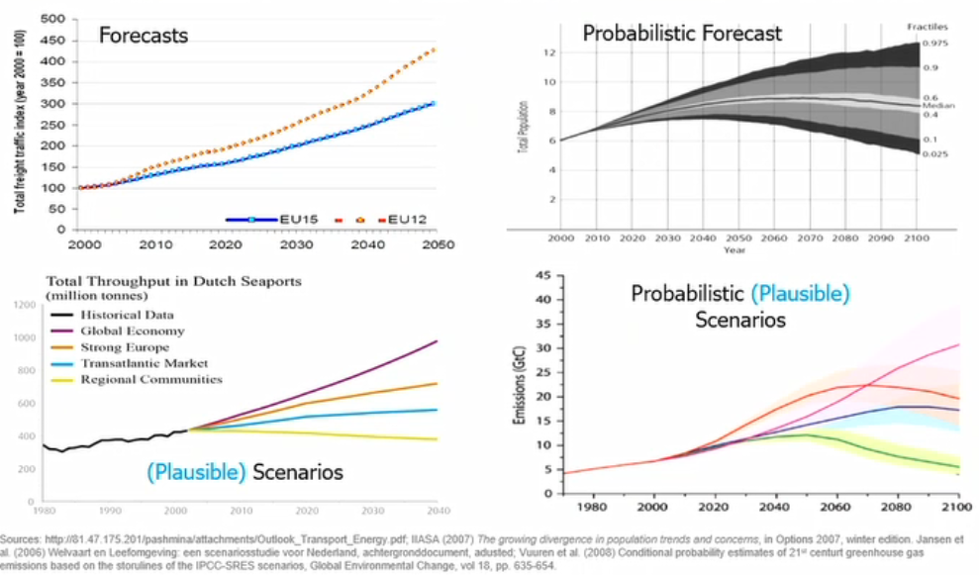

* + 1. Two Distinctive Port Layouts

High capacity conveyer systems linked to storage. Or unloaders load into trucks and is brought to storage.

#### Application within the model

## Assessing Design Assumptions

Asdfasfdasf

#### Conventional design assumptions

* Allowable waiting time
* Peak factor (?)

#### Assumption assessment

Asdfasdf

#### Results

#### Conclusions

## The Added Value of Forcasting

Introduction

#### Making design rules forecast compatible

* Allowable waiting time
* Peak factor (?)

#### The forecasting window

Asdfasdf

#### Quantifying the added value of forecasting

#### Conclusions



# Case Study

## An Import Terminal in Africa

Introduction

#### Why Africa?

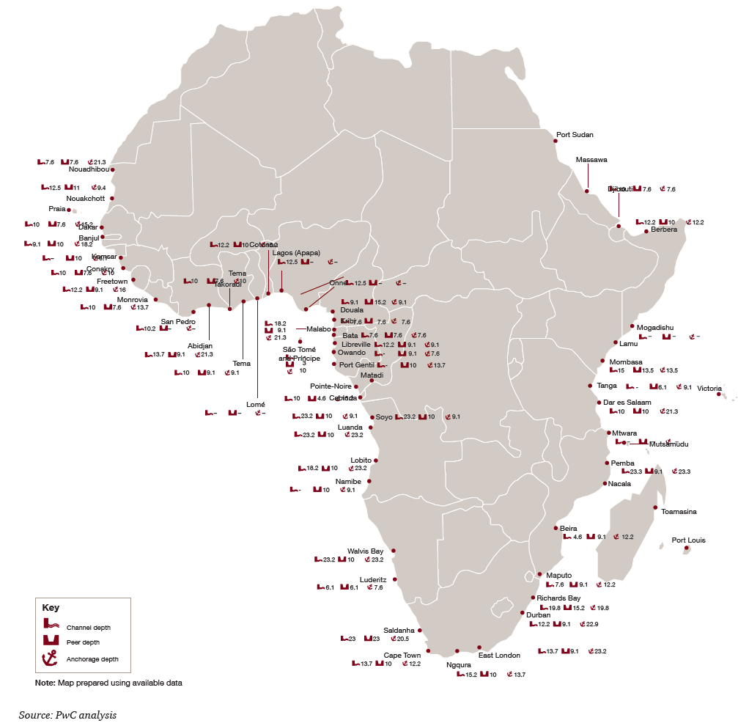

Figure 9.1: Berthing Depths in African Port 51

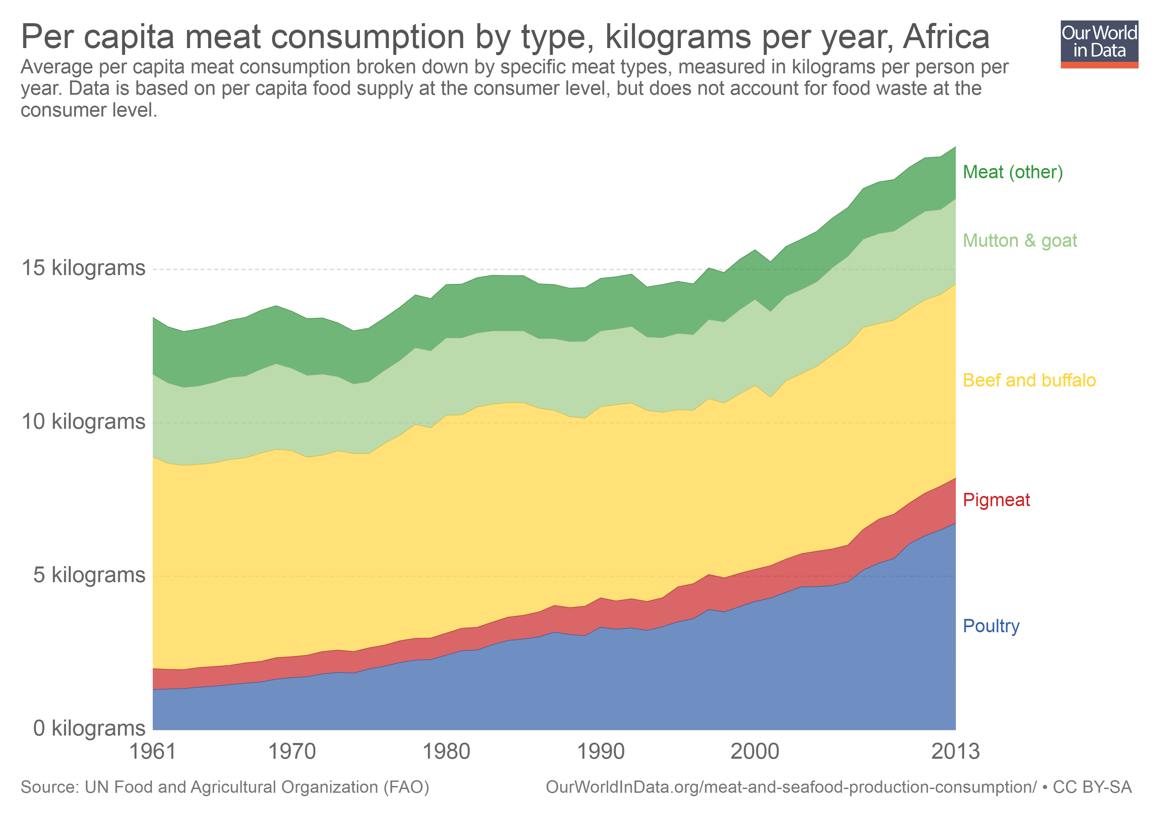

#### Terminal location

Africa aggregated:

Production = Area \* yield

Consumption = human consumption \* population + meat consumption \* feed-fed-factor \* livestock distribution \* feed-conversion ratio

Trade potential = Consumption - Production

These trends will form the basis for traffic scenario’s set out in chapter 10 case study

Focus on Nigeria



Heat map for current import volumes

GDP per country

Wheat consumption per country

Wheat production per country

Wheat import per country

Maize consumption per country

Maize production per country

Maize import per country

Soybean consumption per country

Soybean production per country

Soybean import per country

“Our projections of food demand are derived, as a first step, as functions of projected per capita GDPs, using different Engel functions for the different commodities and countries. The projected per capita GDPs are exogenous variables to our agricultural projections exercise and come from other sources that specialize in economy-wide analyses and modelling”6

#### Applied economic projections

Asdfasdf

* + 1. Traffic scenario’s

Asdfasdf

* + 1. Forecasting method

Asdfasdf

* + - 1. Forecast window

Asdfasdf

#### Resulting terminal

Asdfasdf

#### Conclusions

Asdfasdf



Notes

1. Population
2. GDP per capita
3. Crop consumption + Meat consumption
   1. Crop consumption based on historic correlation with population
   2. Meat consumption benchmarked on surrounding
4. Meat consumption 🡪 Crop demand
   1. Production of poultry and pigs is solely met by feed
   2. Production of cattle and sheep is partly done by feed and partly done by pastures (23% feed in 2011)28
   3. Step 1 – produced weight multiplied by FCR
   4. Step 2 – poultry and pigs are 100% feed and bovine and sheep is 23% feed
5. Own production
   1. Current area for crop production
   2. Yields per hectare
   3. Yield trend per hectare
   4. Area \* yield = production
   5. If net importer, assumption that there is no export
6. Crop demand – own production = import



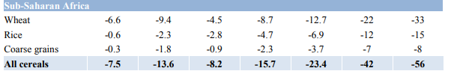

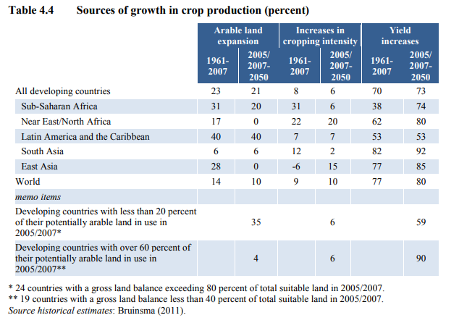  
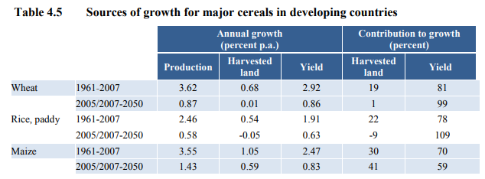

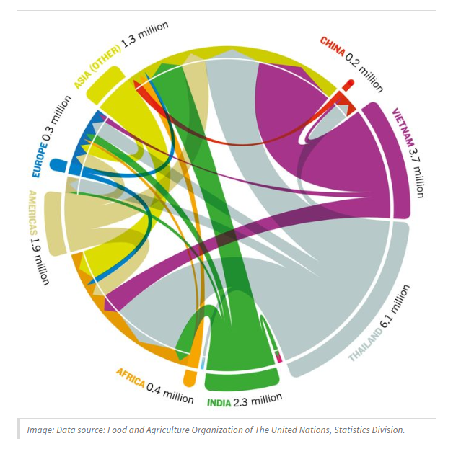

# Conclusions and Recommendations



## Conclusions

Introduction

#### Research into investment triggers

asdfdasf

#### The added value of integrating forecasts into the design process

asdfafd

## Recommendations

Introduction

#### Investment triggers

asdfdasf

#### Forecasting mechanism

asdfafd

asdfas

#### Expand terminal element scope

Jetties

Trucks on the terminal instead of conveyors

Navigational services

Terminal downtime

#### Expand project phase scope

Economics and port planning are intertwined as they go hand in hand in the following five design stages:

* Cargo projections: expected throughput columes, tarigg levels and resulting revenues
* Port design: port engineer prepares design which is then translated into capital expenditures (capex) and operational expenditures (opex)
* Financial evaluation: economists analyse the financial feasibility of the project and take into account inflation rates, depreciation levels, finance structure and tax payments.
* Economic evaluation: economists analyse the project feasibility from an economic perspective, which includes the the (non)desirable effects from a societal point of view. Required for sibsidies and grants
* Project funding: financial expert investigates the options to fund the project by creating conditions in which the returns and risk level of the project are acceptable to the lender, unlocking the capital required to initiate the project

This research only focusses on step one and two, in cluding more phases into the scope may lead to a better streamlines design process. Due to the multidisciplinary nature of all five steps it may be inefficient to try to combine all steps into a single assessment of tool, however, examining the interfaces between these different steps and their resepective areas of expertises may ultimately lead to efficiency gains taken over the entire process leading up to the final investment dicision of terminal projects.

# Appendix



## Model Validation

Introduction

#### Investment triggers

asdfdasf

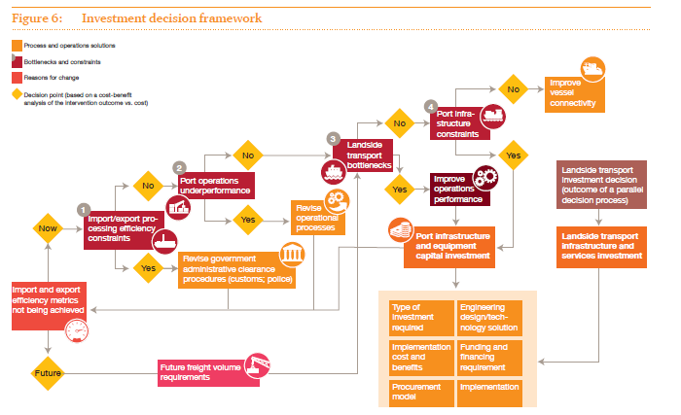

Figure 1.1: Port Optimization Cycle 51

## Bibliography

1. USDA. Grain: World Markets and Trade. 25 (2018).

2. Bodirsky, B. L., Rolinski, S., Biewald, A. & Weindl, I. Global Food Demand Scenarios for the 21 st Century. *PLoS One* 1–27 (2015). doi:10.5281/zenodo.31008

3. OECD. UN population projections. Available at: https://population.un.org/wpp/Download/Standard/Population/.

4. OECD. Long term GDP forecasts.

5. Elferink, E. V., Nonhebel, S. & Moll, H. C. Feeding livestock food residue and the consequences for the environmental impact of meat. *J. Clean. Prod.* **16,** 1227–1233 (2008).

6. FAO. World Agriculture: towards 2030/2050. (2012). doi:10.1016/S0264-8377(03)00047-4

7. Food and Agriculture Organization of the United Nations. *FAOSTAT Database*. (2014).

8. UN Population Division. World Population Propects. (2017). Available at: https://esa.un.org/unpd/wpp/.

9. OECD. OECD GDP Forecasts. (2018). Available at: https://data.oecd.org/gdp/real-gdp-forecast.htm.

10. FAO. Global Food Consumption. Available at: https://ourworldindata.org/meat-and-seafood-production-consumption#per-capita-trends-in-meat-consumption.

11. The World Bank. The World Bank. Available at: https://data.worldbank.org/indicator/NY.GDP.MKTP.CD?end=2010&locations=BR&start=2000. (Accessed: 20th May 2018)

12. PIANC. *Report n° 158 - 2014 Masterplans for the development of existing ports*. (2014).

13. Clarksons. Dry Bulk Trade Outlook. **23,** (2018).

14. Kox, S. A. J. A Tool for Determining Marine Terminal Dimensions and Costs in a Project’s Feasibility Phase. 203 (2016).

15. Dragović, B., Tzannatos, E. & Park, N. K. Simulation modelling in ports and container terminals: literature overview and analysis by research field, application area and tool. *Flex. Serv. Manuf. J.* **29,** 4–34 (2017).

16. Harris, G. a., Holden, A. R., Schroer, B. J. & Möeller, D. P. F. A Simulation Approach to Evaluating Productivity Improvement at a Seaport Coal Terminal. *Transp. Res. Rec. J. Transp. Res. Board* **2062,** 19–24 (2008).

17. van den Brand, S. Storage sharing at import dry- bulk terminals: a case study at Gadani Energy Park. (2017). doi:803ceabb-64ff-4ee7-a521-ddafe81fb15d

18. van Vianen, T. *Simulation-integrated Design of Dry Bulk Terminals*. (2015).

19. Wu, M.-R. *A Large-Scale Biomass Bulk Terminal*. (2012).

20. Wiegmans, B. & Schott, D. Incorporating commodity flexibility in terminal design : Strategies to change commodities at a terminal. **00,** (2017).

21. FAO. The Wheat Initiative – an International Research Initiative for Wheat Improvement Context – the problems being addressed. *Second Glob. Conf. Agric. Res. Dev.* (2012).

22. Ranum, P., Peña-Rosas, J. P. & Garcia-Casal, M. N. Global maize production, utilization, and consumption. *Ann. N. Y. Acad. Sci.* **1312,** 105–112 (2014).

23. IOP Science. Crop Calorie Data. (2003).

24. Herrero, M. *et al.* Biomass use, production, feed efficiencies, and greenhouse gas emissions from global livestock systems. *Proc. Natl. Acad. Sci.* **110,** 20888–20893 (2013).

25. OEC. OEC Trade Atlas. (2018). Available at: https://atlas.media.mit.edu/en/.

26. IMF. IMF GDP Forecasts. (2018). Available at: http://www.imf.org/external/datamapper/NGDP\_RPCH@WEO/WEOWORLD/AFQ/CHN/IND.

27. Lee, B. *et al.* Resources Futures. 249 (2012).

28. Alexander, P., Brown, C., Arneth, A., Finnigan, J. & Rounsevell, M. D. A. Human appropriation of land for food: The role of diet. *Glob. Environ. Chang.* **41,** 88–98 (2016).

29. Banaszkiewicz, T. Nutritional Value of Soybean Meal. *Soybean Nutr.* 1–20 (2011). doi:10.5772/1008

30. Kleinmans, J. J., Densley, R. J., Hurley, T., Williams, I. D. & Calvert, F. Brief communication: Feed value of maize silage in New Zealand - a review. *Proc. New Zeal. Soc. Anim. Prod.* **76,** 100–102 (2016).

31. Daas, E. Bunge Interview. (2018).

32. Davis, K. F. & D’Odorico, P. Livestock intensification and the influence of dietary change: A calorie-based assessment of competition for crop production. *Sci. Total Environ.* **538,** 817–823 (2015).

33. UNCTAD. *Review of Maritime Transport*. *New York* (2009). doi:10.1039/c2py00503d

34. Clarksons. *Carrier Register*. (2018).

35. Karamperidou, A. “ Parametric Analysis of Quay Walls with Relieving Platform , by means of Elastic Supported Beam and Finite Element Method ”.

36. de Gijt, J. G. & Broeken, M. L. *Quay Walls*. (2014).

37. de Gijt, J. G. A History of Quay Walls. PhD dissertation. (2010).

38. Kuo, T., Huang, W., Wu, S. & Cheng, P. A CASE STUDY OF INTER-ARRIVAL TIME DISTRIBUTIONS OF CONTAINER SHIPS. **14,** 155–164 (2006).

39. Douma, A. ., Schuur, P. & Jagerman, R. Degrees of terminal cooperativeness and the efficiency of the barge handling process. *Expert Syst. Appl.* 3580–3589 (2011).

40. Ligteringen, H. & Velsink, H. *Ports and Terminals*. (Delft Academic Press, 2017).

41. Verschoof, I. J. Cranes, Design Practice and Maintenance. *Prof. Eng. Publ.* **2nd Editio,** (2002).

42. Kranendonk, C. IGMA Interview. (2018).

43. Corbeau, M. Nemag Interview. (2018).

44. Miedema, S. A. A Sensitivity Analysis of the Production of Clamshells. 181–200 (2006).

45. UNCTAD. *Port Development: A Handbook For Planners In Developing Countries*. (1985). doi:10.1007/978-1-84882-997-8\_16

46. Verstegen. Bulk handling grabs - Verstegen. (2018). Available at: https://www.verstegen.net/grabs/. (Accessed: 25th April 2018)

47. Nemag. The Clamshell Grab. (2018).

48. Schutz, R. IGMA Interview. (2018).

49. Imai, A., Sun, X., Nishimura, E. & Papadimitriou, S. Berth allocation in a container port: Using a continuous location space approach. *Transp. Res. Part B Methodol.* **39,** 199–221 (2005).

50. Rodrigues, I. B. G., Rosa, R. de A., Gomes, T. C. & Ribeiro, G. M. Mathematical model for the Berth Allocation Problem in ports with cargo operation limitations along the pier. *Gestão & Produção* **23,** 0 (2016).

51. PWC. *Strengthening Africa’s gateways to trade*. (2018).

The Pearl in the Shell  
Unlocking Value in the   
Maritime & Transport Industry

Maritime & Transport Business Solutions

|  |  |  |
| --- | --- | --- |
| **address** |  | Wijnhaven 3E |
|  |  | P.O. BOX 601 |
|  |  | 3011 WG Rotterdam  The Netherlands |
| **telephone** |  | +31 (0)10 286 59 40 |
| **e-mail** |  | info@mtbs.nl |
| **internet** |  | www.mtbs.nl |

